Video Frame Processing

Contents

Introduction 8

Architecture 9

Features 10

Clocks 11

CMOS pixel Capture 11

VFP 12

HSL COLOR SPACE 13

HSV COLOR SPACE 18

HSL COLOR RANGE SPACE 21

cmyk COLOR SPACE 24

ydrdb COLOR SPACE 25

CIEXYZ COLOR SPACE 26

CIEYUV COLOR SPACE 27

Yiq COLOR SPACE 28

YPBPR COLOR SPACE 29

I1I2I3 OHTA COLOR INTENSITIES 30

lms COLOR SPACE 31

ictcp COLOR SPACE 32

HED COLOR SPACE 33

YC1C2 COLOR SPACE 34

Sharp Filter 35

Blur Filter 36

Emboss Filter 37

Sobel Filter 38

YCbCr Color Space 39

Color Adjust Matrix 40

Local Dynamic Threshold Segmentation 48

IMAGE CONTRAST AND BRIGHTNESS 49

Camera Raw Data 49

Image Read Interface 50

Three Taps data 51

Four Taps data 51

Pixel Coordinates 51

Camera Raw Data 53

Histogram 56

TESTBENCH COMPONENTS/OBJECTS 57

SEQUENCE ITEM 61

SEQUENCE 61

SEQUENCER 61

DRIVER 61

AGENT 68

SCOREBOARD 68

ENVIRONMENT/ENV 68

TEST 68

TESTBENCH_TOP 69

Color differences 72

Hue and Chroma 72

Figure 1 8

Figure 2 : Video Frame Processing Skeleton Architecture 9

Figure 3 12

Figure 4 13

Figure 5 13

Figure 6 13

Figure 7 : HSL Filter Wave Diagram 14

Figure 8: Hue Numerator Logic 14

Figure 9: Hue Denominator Logic 14

Figure 10: Hue Degree Logic 14

Figure 11: RGB image 15

Figure 12: HSL converted image 15

Figure 13: RGB image 15

Figure 14: HSL converted image 15

Figure 15: HSL Image 15

Figure 16: Hue channel 15

Figure 17: Saturate channel 15

Figure 18: Luminosity channel 15

Figure 19: HSL Image 15

Figure 20: Hue channel 15

Figure 21: Saturate channel 15

Figure 22: Luminosity channel 15

Figure 23 16

Figure 24 16

Figure 25 16

Figure 26 16

Figure 27 16

Figure 28 17

Figure 29 18

Figure 30 18

Figure 31 18

Figure 32 19

Figure 33 19

Figure 34 19

Figure 35 19

Figure 36 19

Figure 37 19

Figure 38 19

Figure 39 19

Figure 40 19

Figure 41 19

Figure 42 19

Figure 43 19

Figure 44 20

Figure 45 20

Figure 46 20

Figure 47 20

Figure 48 21

Figure 49 21

Figure 50 21

Figure 51 21

Figure 52 21

Figure 53 21

Figure 54 21

Figure 55 21

Figure 56 21

Figure 57 21

Figure 58 21

Figure 59 21

Figure 60 22

Figure 61 22

Figure 62 22

Figure 63 22

Figure 64 22

Figure 65 22

Figure 66 22

Figure 67 22

Figure 68 22

Figure 69 22

Figure 70 22

Figure 71 22

Figure 72 23

Figure 73 23

Figure 74 23

Figure 75 23

Figure 76 23

Figure 77 23

Figure 78 23

Figure 79 23

Figure 80 24

Figure 81 24

Figure 82 24

Figure 83 24

Figure 84 24

Figure 85 24

Figure 86 25

Figure 87 25

Figure 88 25

Figure 89 25

Figure 90 26

Figure 91 26

Figure 92 26

Figure 93 26

Figure 94 27

Figure 95 27

Figure 96 27

Figure 97 27

Figure 98 28

Figure 99 28

Figure 100 28

Figure 101 28

Figure 102 29

Figure 103 29

Figure 104 29

Figure 105 29

Figure 106 30

Figure 107 30

Figure 108 30

Figure 109 30

Figure 110 30

Figure 111 31

Figure 112 31

Figure 113 31

Figure 114 31

Figure 115 32

Figure 116 32

Figure 117 32

Figure 118 32

Figure 119 33

Figure 120 33

Figure 121 33

Figure 122 33

Figure 123 34

Figure 124 34

Figure 125 34

Figure 126 34

Figure 127 35

Figure 128 36

Figure 129 39

Figure 130 40

Figure 131 : camera raw data module 49

Figure 132 : General view of camera raw data flow 50

Figure 133 50

Figure 134 51

Figure 135 51

Figure 136 51

Figure 137 52

Figure 138 53

Figure 139 56

Figure 140 57

Figure 141 60

Figure 142 60

Figure 143 62

Introduction

The purpose of this design to take raw Bayer format data and convert into video 16-bit YCbCr [4:2:2] (YUV) color space. This design reads camera input data, then transform into rgb color space of 24-bit data bus with 8 bits each for the red pixel, green pixel, and blue pixel. Each rgb pixel either filtered or converted into color space. Sharp, blur, emboss and sobel filtered are used in this design. RGB into Ycbcr and color correction space are implemented in this design.

Image frame resolution is set to 1920x1080 at 23 frames per second and maximum full resolution of 2592x1944 is also supported but limited to 15 frames per second.

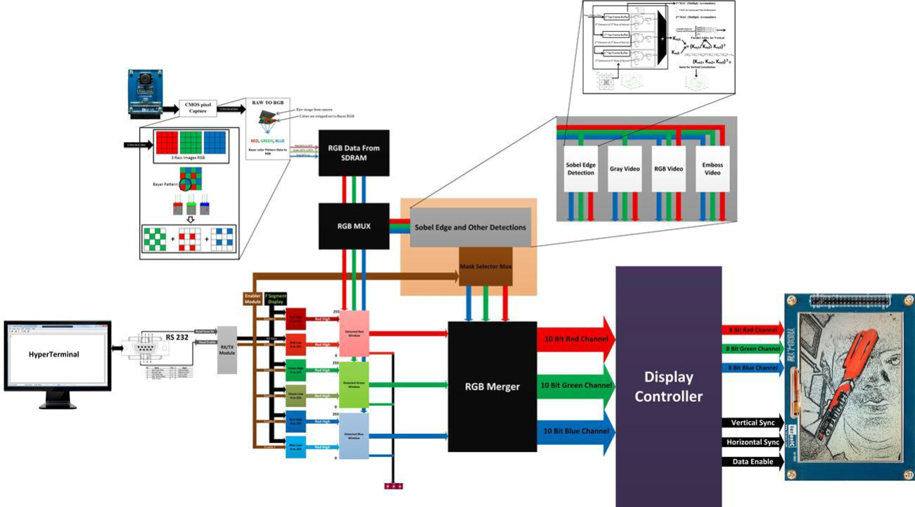

Figure

The idea of this project is to design and develop a stand-alone, FPGA-based smart camera that can perform the processing tasks such as Sobel, Prewitt, dilation edge detection, color object detection, emboss effects and output the alarm signal in the case of detection to short-range wireless systems using the zigbee. With the rapid development of remote sensing camera has become a popular sensor device for monitoring and surveillance systems. It is the first step of video analysis and understanding with remote sensing video especially the detection of object which is necessary step to extract the information from stream of binary raw data from the sensors. The purpose of the detection is to discover the information about the identified object in the presence of the surrounding objects. The sensor device used is a THDB-D5M, which is five mega pixel digital CMOS color image sensor, and it contains a power voltage circuit, a low noise amplifier and clock driver circuit. Its flexibility and ease of use makes it a good choice for the system. The raw data of color video stream and edge detection is very large, so speed of video processing is a difficult problem. Therefore, in order to improve the performance of real time video processing FPGA is an effective device to realize real-time parallel processing of vast amounts of video data. Moreover, adopting FPGA as a development platform than PC and other IC is to perform data intensive video processing tasks with real requirements. Therefore, architecture of detection is designed with a FPGA chip called Cyclone II 2C70, and it can process 800 x 480 x 10 RGB color scale video successfully. This device can locate the detected color object and the edge of the gray frame quickly and efficiently.

Architecture

The Video processing frame core provides a modular expandable interface for video frame processing.

General architecture consists of camera interface module “camera_raw_to_rgb” which convert bayer format data into rgb format” rgb_set”. Video stream module which filters rgb data into various filters and axis external module which stream the filtered data to axi4-stream.

The idea behind to use the D5M camera for the FPGA was to have the easy connection of 40 pins between these two devices. This 40 pins connection provide input/output communication using the pixel clock, pixel data (12 bits), power (3.3V), Serial clock, serial data(I2C), frame valid and line valid. A typical camera system is shown in figure 1. At the heart of every digital camera is an image sensor either CCD image senor or a CMOS sensor. Both types of sensors capture the light through the lens and convert into the electrical signal which is further processed by ADC. Nowadays, majority of sensors consist of high-performance ADC converters which are employed to produce the digital output. Most CMOS image sensors have ADC resolutions of 10 to 12 bits. In this project, D5M camera has 12 bits ADC resolution. The D5M pixel array consists of a 2752-coloumn by 2004-row matrix. The pixel array is addressed by column and row. The array consists of a 2592-column by 1944-row active region and a border region as shown below. The output images are divided into frames, which are further divided into lines. The output signals frame valid and lines valid are used to indicate the boundaries between the lines and frames [3]. Pixel clock is used as a clock to latch the data. For each pixel clock cycle, one 12-bit pixel data outputs on the data out pins [3]. When both frame valid and line valid are asserted, the pixel is valid. Pixel clock cycles that occur when frame valid is negated are called vertical blanking. Pixel clock cycles that occur when only line valid is negated are called horizontal blanking. The camera has an array of 255 register, a lot of them are configurable, and it is possible to set up the operation of the camera by writing to these registers. This communication is performed using a generic two wire serial interface commonly referred to as I2C[3]. There are two different communication modes, control / configuration mode which included read/write values to the register in the D5M card, and pixel data read out which consists of reading the pixel data from the camera card [3].



Figure : Video Frame Processing Skeleton Architecture

Features

Input format: Raw Bayer format

Output format: 16-bit YCbCr [4:2:2] (YUV) color space

24-bit User AXI Stream input.

**Filters:**

1. HSL
2. HSV
3. Sharp
4. Blur
5. Emboss
6. Sobel
7. YCbCr
8. Color Adjust Correction

Clocks

There are two clocks used in this design, pixel clock is nominally the pixel clock rate, with a

set pll programed design frequency of 96MHz or below, and system clock which is a 150 Mhz.

CMOS pixel Capture

This is the first module inside the FPGA which communicate with camera. It receives the data of 12 bits per pixel at each clock cycle from the cmos camera when the frame valid and line valid are asserted high. Pixel clock (50MHz) is used to latch the data on the rising edge of the clock. In the case of when clear is set, then it captures on the falling edge of the pixel clock. Vertical blank occurs when frame valid is high. However, horizontal blank only occurs when both frames line valid and frame valid are high. In order to pause, restart, snapshot and change the exposure level of the video, certain registers need to be assigned the hex values. These hex values are given in the datasheet of this camera. Setting these values will enable the features and functionality of the camera. These features were enabled by using the I2C bus which has two wires SDA and SCL. SDA is the data line. SCL is the clock line which is used to synchronize all data transfers over the I2C bus. The SCL & SDA lines are connected to the FPGA and the camera on the I2C bus. Once the registers were assigned the values and valid signal are asserted, the camera output the 12 bits data at the maximum data rate of 96Mp/s. Input clock for the camera is 96MHz which gives the maximum data rate, but this data rate should be latched at the 50MHz clock. Active pixels: 2,592H x 1,944V Pixel size: 2.2μm x 2.2μm Color filter array RGB Bayer pattern Full resolution Programmable up to 15 fps Frame rate VGA (640 x 480) Programmable up to 70 fps ADC resolution: 12-bit Pixel dynamic range: 70.1dB SNRMAX: 38.1dB Supply Power Voltage: 3.3V I/O Voltage: 1.7V～3.1V

VFP

Prior to the implementation of the various filters, it necessary to overview top module and io connections to internal modules. Generic defined in vfp give user option to select various filter, config axi4-lite address/data bus width and set revision number. The TDATA_WIDTH generic specifies the number of bits in a word and the ADDR_WIDTH specifies the number of address bits, which implies that there are 2^ADDR_WITH words. BMP_WIDTH AND BMP_HEIGHT specifies image frame width and height.

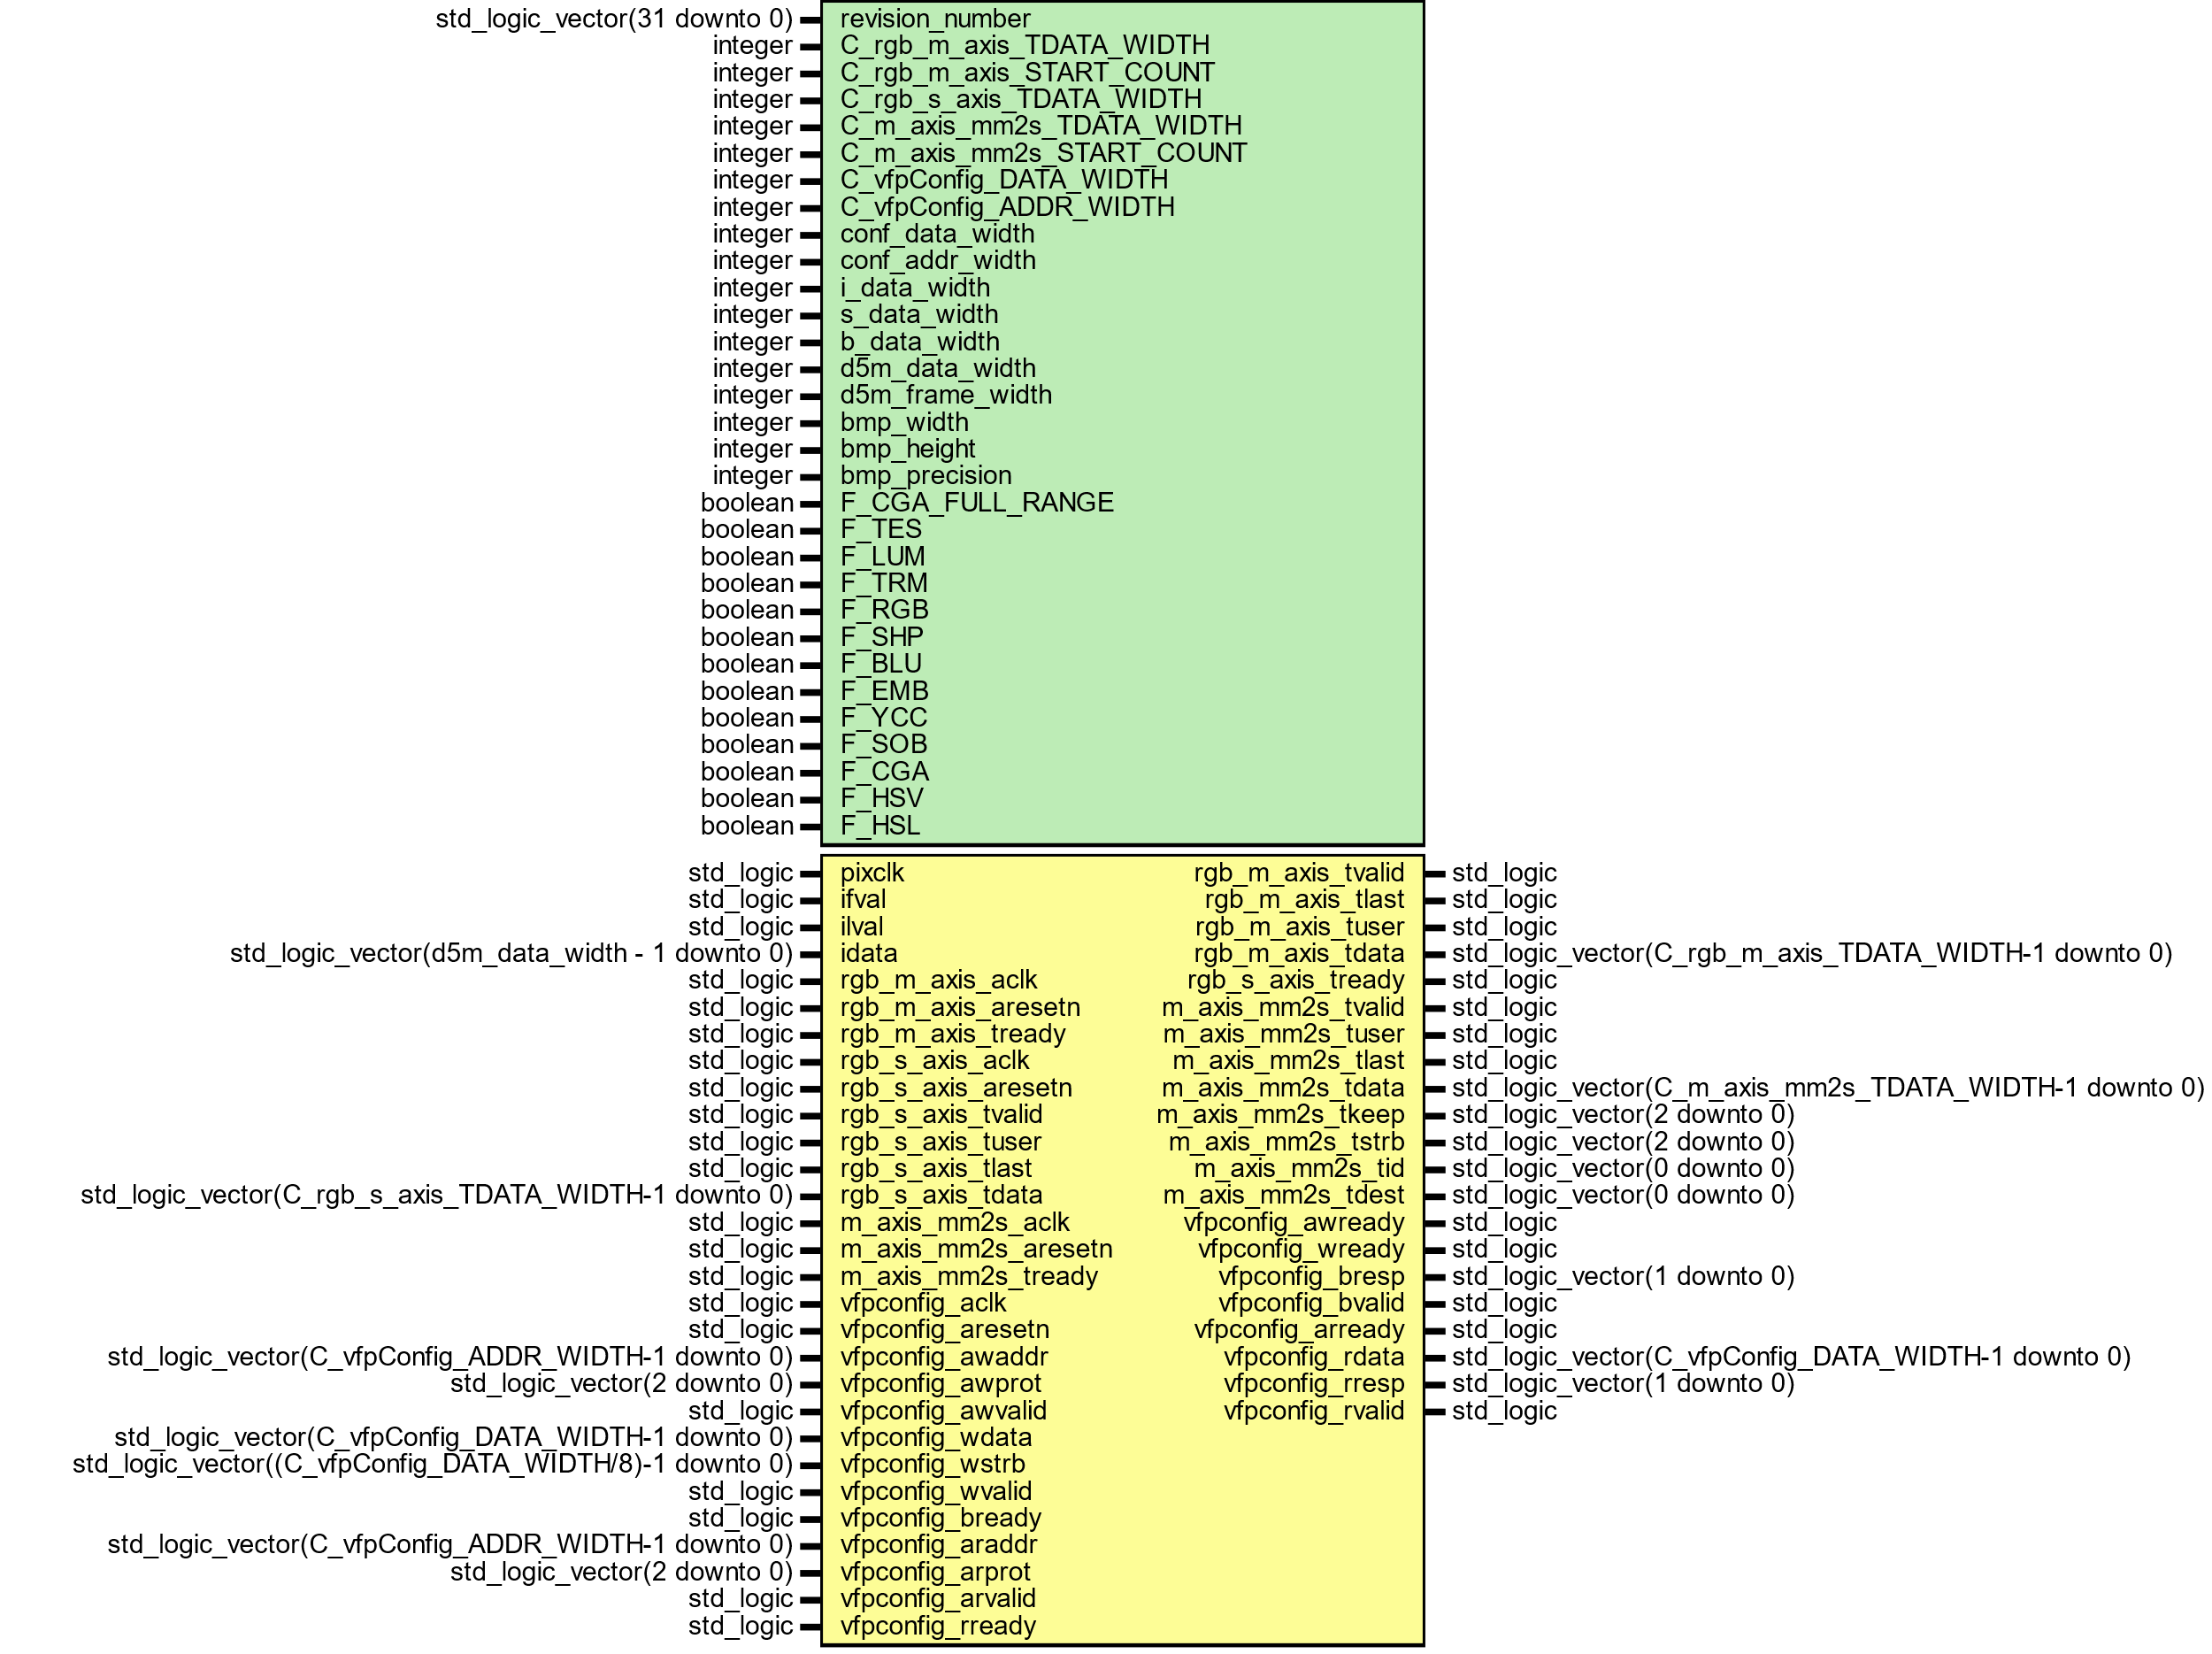

Figure

HSL COLOR SPACE

This module converts rgb color space to hsl color space. First logic calculates maximum and minimum value of rgb values. Hue is calculated first determining the hue fraction from greatest rgb channel value. If current max channel is red than Hue numerator will be set to be green subtract blue only if green is greater than blue else blue is subtracted from green and Hue degree would be zero. If current max channel is green than Hue numerator will be set to be blue subtract red only if blue is greater than red else red is subtracted from blue and Hue degree would be 129. Similarly, if current channel is blue than Hue numerator will be set to be red subtract green only if red is greater than green else green subtracted from red and Hue degree would be 212. Hue denominator would be rgb delta. Once Hue fraction values are calculated than fraction values would be added to hue degree which would give final hue value as done logic. Saturate value is calculated from difference between rgb max and min over rgb max whereas Lightness value rgb max value.

HSV, HSL and HSI: Hue is a color range degree from 0 degree to 360 degree. Saturate is shade of gray to full color. Amount of saturation of color is known as chroma. Higher value of chroma is clear and bight. The strongest magnitude is value and its range correspond to brightness and balanced magnitude corresponds to the intensity.

From RGB triplet saturation equation shown below where max is calculated of between red, green and blue channel.

$$saturate=\frac{\left(max⁡(rgb)-min⁡(rgb)\right)}{max⁡(rgb)}$$

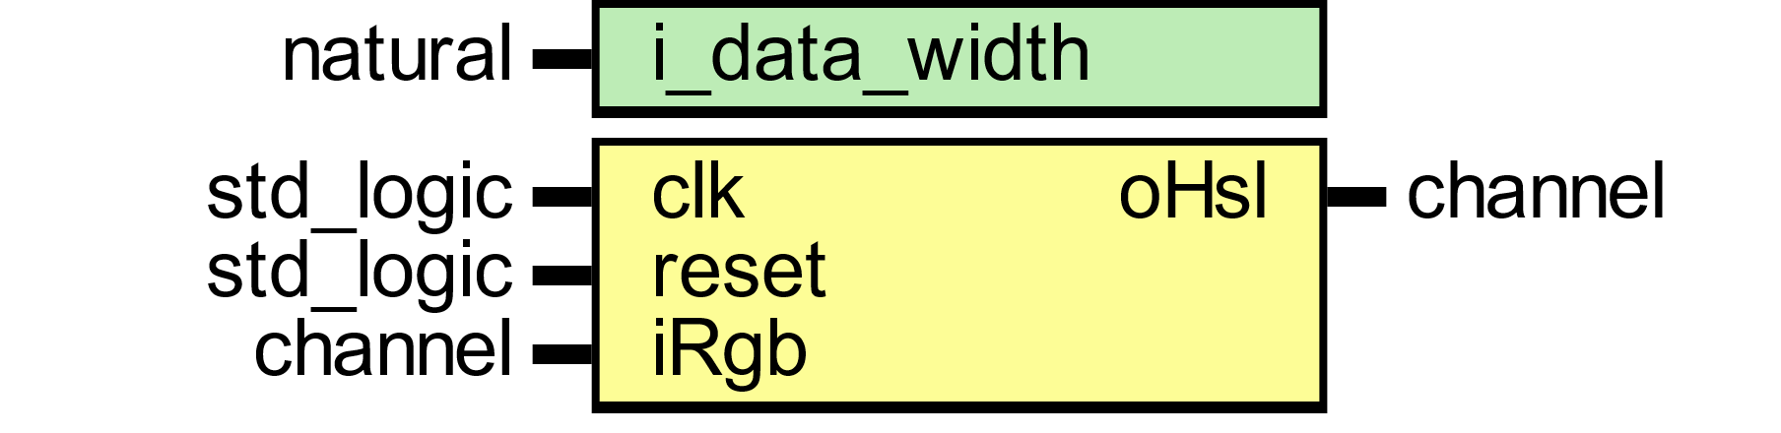

Figure 4

|  |  |
| --- | --- |
| A picture containing shape  Description automatically generated  Figure 5 | A picture containing background pattern  Description automatically generated  Figure 6 |

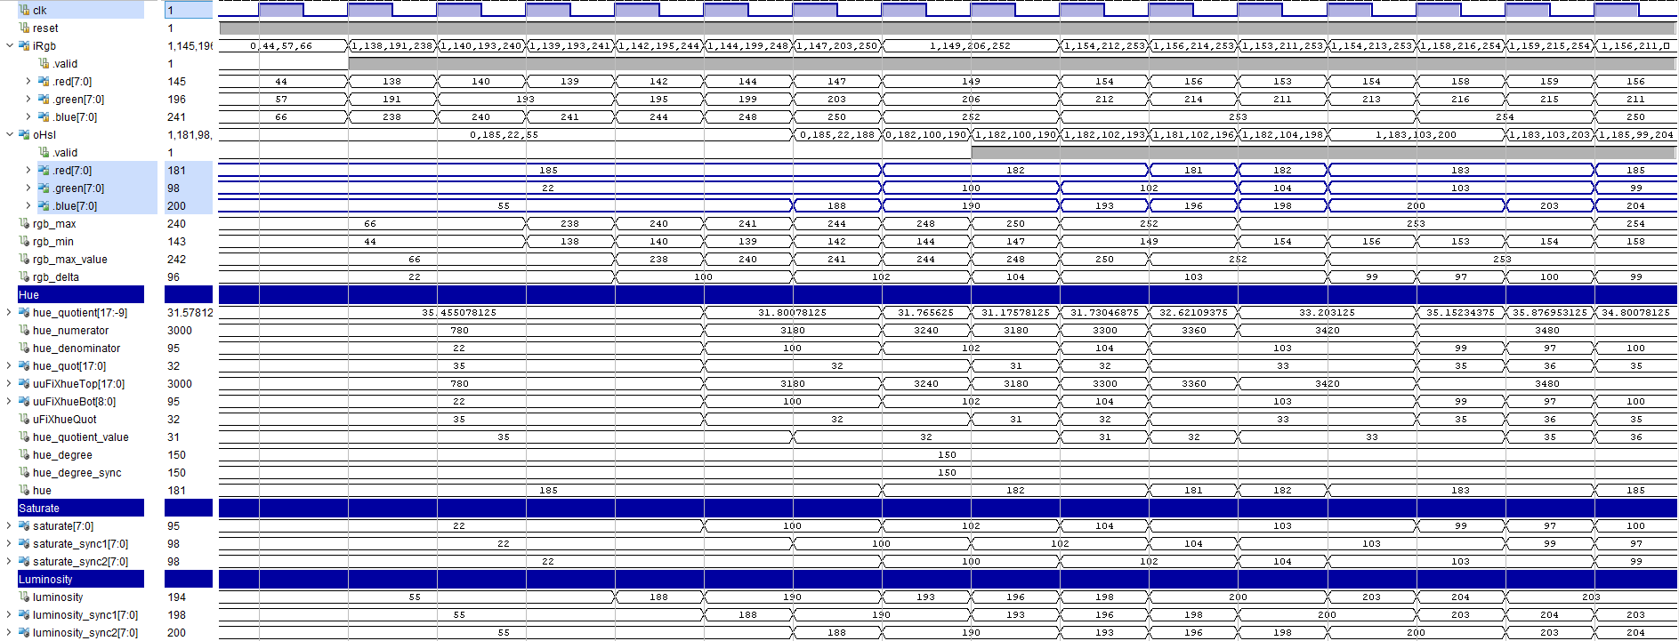

Figure : HSL Filter Wave Diagram



Figure 8: Hue Numerator Logic



Figure 9: Hue Denominator Logic



Figure 10: Hue Degree Logic

Below figures shows rgb color space conversion implementation into six regions of the hexagon images. The representation of the RGB color space shown in 1st and 3rd figure.

|  |  |  |  |
| --- | --- | --- | --- |
| Figure 11: RGB image | Figure 12: HSL converted image | Figure 13: RGB image | Figure 14: HSL converted image |
| 1st and 3rd figure are rgb image and whereas 2nd and 4th are hsl simulated results. | | | |
| Figure 15: HSL Image | Figure 16: Hue channel | Figure 17: Saturate channel | Figure 18: Luminosity channel |
| Figure 19: HSL Image | Figure 20: Hue channel | Figure 21: Saturate channel | Figure 22: Luminosity channel |
| 1st image is hsl image, 2nd represent hue channel, 3rd saturate channel and 4th luminosity channel.   |  |  |  |  | | --- | --- | --- | --- | |  |  |  |  | | 1ST figure shows rgb image. 2nd figure shows red channel. 3rd figure shows green channel and 4th figure shows blue channel. | | | | | | | |
| |  |  | | --- | --- | | Figure 23 |  | | Figure 24 | Figure 25 | | Figure 26 | Figure 27 | | A picture containing cup, indoor, pot, bin  Description automatically generated  Figure 28 |  | | | | |
| 1st image is hsl image, 2nd represent hue channel, 3rd saturate channel and 4th luminosity channel.  HSL is cylindrical geometry with hue, angular dimension colors transition from red to orange, yellow, green, cyan, blue, magenta. | | | |
|  | | | |
|  | | | |

HSV COLOR SPACE

This module converts rgb color space to hsl color space. First logic calculates maximum and minimum value of rgb values. Hue is calculated first determining the hue fraction from greatest rgb channel value. If current max channel is red than Hue numerator will be set to be green subtract blue only if green is greater than blue else blue is subtracted from green and Hue degree would be zero. If current max channel is green than Hue numerator will be set to be blue subtract red only if blue is greater than red else red is subtracted from blue and Hue degree would be 129. Similarly, if current channel is blue than Hue numerator will be set to be red subtract green only if red is greater than green else green subtracted from red and Hue degree would be 212. Hue denominator would be rgb delta. Once Hue fraction values are calculated than fraction values would be added to hue degree which would give final hue value as done logic. Saturate value is calculated from difference between rgb max and min over rgb max whereas Intensity value rgb max value.

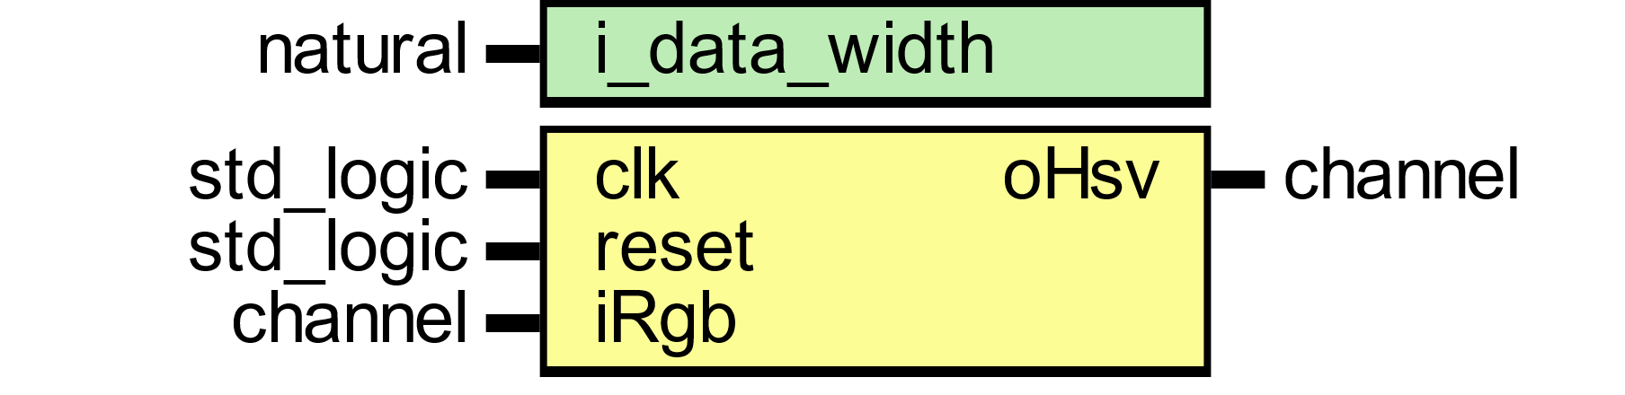

Figure

|  |  |
| --- | --- |
| A picture containing shape  Description automatically generated  Figure 30 | A picture containing shape  Description automatically generated  Figure 31 |

|  |  |  |  |
| --- | --- | --- | --- |
| Figure | Figure | Figure | Figure |
| 1st and 2nd figure are rgb image and whereas 3rd and 4th are hsl simulated results. | | | |
| Figure | Figure | Figure | Figure |
| 1st and 2nd figure are rgb image and whereas 3rd and 4th are hsl simulated results. | | | |
| Figure | A picture containing stationary  Description automatically generated  Figure | Shape  Description automatically generated  Figure | Figure |
| 1st and 2nd figure are rgb image and whereas 3rd and 4th are hsl simulated results. | | | |
| Figure | Figure | Figure | Figure |
| 1ST figure shows rgb image. 2nd figure shows red channel. 3rd figure shows green channel and 4th figure shows blue channel. | | | |

HSL COLOR RANGE SPACE

|  |  |  |  |
| --- | --- | --- | --- |
| Figure | Figure | Figure | Figure |
| 1ST figure shows rgb image. 2nd figure shows red channel. 3rd figure shows green channel and 4th figure shows blue channel. | | | |
| Figure | Figure | Figure | Figure |
| 1ST figure shows rgb image. 2nd figure shows red channel. 3rd figure shows green channel and 4th figure shows blue channel. | | | |
| Figure | Figure | Figure | Figure |
| 1ST figure shows rgb image. 2nd figure shows red channel. 3rd figure shows green channel and 4th figure shows blue channel. | | | |
| Figure | Figure | Figure | Figure |
| 1ST figure shows rgb image. 2nd figure shows red channel. 3rd figure shows green channel and 4th figure shows blue channel. | | | |

|  |  |  |  |
| --- | --- | --- | --- |
| Figure | Figure | Figure | Figure |
| 1ST figure shows rgb image. 2nd figure shows red channel. 3rd figure shows green channel and 4th figure shows blue channel. | | | |
| Figure | Figure | Figure | Figure |
| 1ST figure shows rgb image. 2nd figure shows red channel. 3rd figure shows green channel and 4th figure shows blue channel. | | | |
| Figure | Figure | Figure | Figure |
| 1ST figure shows rgb image. 2nd figure shows red channel. 3rd figure shows green channel and 4th figure shows blue channel. | | | |
| Figure | Figure | Figure | Figure |
| 1ST figure shows rgb image. 2nd figure shows red channel. 3rd figure shows green channel and 4th figure shows blue channel. | | | |

cmyk COLOR SPACE

CMYK (Cyan, Magenta, Yellow, Key/Black) is the color space for printed materials.

|  |  |
| --- | --- |
| A picture containing shape  Description automatically generated  Figure 80 | Shape  Description automatically generated  Figure 81 |
| A picture containing colorful, pallette, several  Description automatically generated  Figure 82 | A picture containing pallette  Description automatically generated  Figure 83 |
| A picture containing indoor  Description automatically generated  Figure 84 | Figure 85 |

From these values, the value of colors can be calculated from the following equations:

$$K=1-MAX\left(R,G,B\right)$$

$$C =(1-R-K)(1-K)M=(1-G-K)(1-K)$$ $$Y =(1-B-K)(1-K)$$

ydrdb COLOR SPACE

|  |  |
| --- | --- |
| Figure 86 |   Figure 87 |
| A picture containing indoor  Description automatically generated  Figure 88 | Figure 89 |

The R, G, B tristimulus values converted to Y, DR, DB tristimulus values as follows:

$$\left[\begin{matrix}Y \\ D_{R} \\ D_{B}\end{matrix}\right]=\left[\begin{matrix}0.299 & 0.587 & 0.114 \\ -0.450 & -0.883 & 1.333 \\ -1.333 & -1.160 & 0.217\end{matrix}\right]\left[\begin{matrix}R \\ G \\ B\end{matrix}\right]$$

CIEXYZ COLOR SPACE

|  |  |
| --- | --- |
| A picture containing shape  Description automatically generated  Figure 90 | Figure 91 |
| A picture containing indoor  Description automatically generated  Figure 92 | Figure 93 |

The R, G, B tristimulus values converted to X, Y, Z tristimulus values. The relationship between RGB and the XYZ values expressed by a 3x3 matrix as shown in equation below.

$$\left[\begin{matrix}X \\ Y \\ Z\end{matrix}\right]=\left[\begin{matrix}0.412 & 0.357 & 0.180 \\ 0.212 & 0.715 & 0.072 \\ 0.019 & 0.119 & 0.950\end{matrix}\right]\left[\begin{matrix}R \\ G \\ B\end{matrix}\right]$$

CIEYUV COLOR SPACE

|  |  |
| --- | --- |
| A picture containing shape  Description automatically generated  Figure 94 | Figure 95 |
| A picture containing indoor  Description automatically generated  Figure 96 | Figure 97 |

The R, G, B tristimulus values converted to Y, U, V tristimulus values as follows:

$$\left[\begin{matrix}Y \\ U \\ V\end{matrix}\right]=\left[\begin{matrix}0.299 & 0.587 & 0.114 \\ -0.147 & -0.289 & 0.436 \\ 0.615 & -0.515 & -0.100\end{matrix}\right]\left[\begin{matrix}R \\ G \\ B\end{matrix}\right]$$

Yiq COLOR SPACE

|  |  |
| --- | --- |
| A picture containing shape  Description automatically generated  Figure 98 | Figure 99 |
| A picture containing indoor  Description automatically generated  Figure 100 | Figure 101 |

The R, G, B tristimulus values converted to Y, I, Q tristimulus values as follows:

$$\left[\begin{matrix}Y \\ I \\ Q\end{matrix}\right]=\left[\begin{matrix}0.299 & 0.587 & 0.114 \\ 0.595 & -0.274 & -0.321 \\ 0.211 & -0.522 & -0.311\end{matrix}\right]\left[\begin{matrix}R \\ G \\ B\end{matrix}\right]$$

YPBPR COLOR SPACE

|  |  |
| --- | --- |
| A picture containing shape  Description automatically generated  Figure 102 | Figure 103 |
| Figure 104 | Figure 105 |

The R, G, B tristimulus values converted to Y, PR, PB tristimulus values as follows:

$$\left[\begin{matrix}Y \\ P_{R} \\ P_{B}\end{matrix}\right]=\left[\begin{matrix}0.213 & 0.715 & 0.072 \\ -0.115 & -0.385 & 0.500 \\ 0.500 & -0.454 & -0.046\end{matrix}\right]\left[\begin{matrix}R \\ G \\ B\end{matrix}\right]$$

I1I2I3 OHTA COLOR INTENSITIES

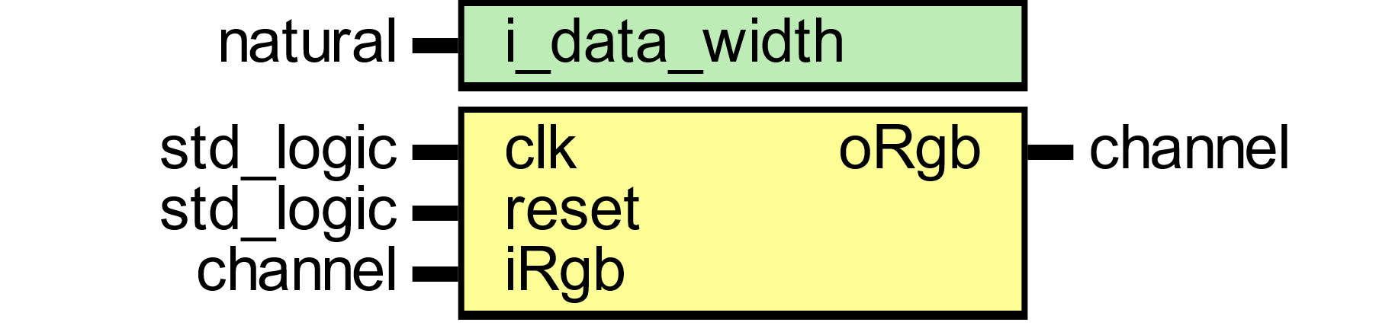

Figure 106

|  |  |
| --- | --- |
| A picture containing shape  Description automatically generated  Figure 107 | A picture containing shape  Description automatically generated  Figure 108 |
| Figure 109 | Figure 110 |

lms COLOR SPACE

|  |  |
| --- | --- |
| A picture containing shape  Description automatically generated  Figure 111 |   Figure 112 |
| A picture containing indoor  Description automatically generated  Figure 113 | Figure 114 |

The R, G, B tristimulus values converted to L, M, S tristimulus values as follows:

$$\left[\begin{matrix}L \\ M \\ S\end{matrix}\right]=\left[\begin{matrix}0.400 & 0.707 & -0.080 \\ -0.228 & 1.150 & 0.061 \\ 0.000 & 0.000 & 0.918\end{matrix}\right]\left[\begin{matrix}R \\ G \\ B\end{matrix}\right]$$

ictcp COLOR SPACE

|  |  |
| --- | --- |
| A picture containing shape  Description automatically generated  Figure 115 | A picture containing shape  Description automatically generated  Figure 116 |
| A picture containing indoor  Description automatically generated  Figure 117 | Figure 118 |

The R, G, B tristimulus values converted to I, CT, CP tristimulus values as follows:

$$\left[\begin{matrix}I \\ C_{T} \\ C_{P}\end{matrix}\right]=\left[\begin{matrix}0.400 & 0.400 & 0.200 \\ 4.455 & -4.851 & 3.960 \\ 8.056 & 3.572 & -1.162\end{matrix}\right]\left[\begin{matrix}R \\ G \\ B\end{matrix}\right]$$

HED COLOR SPACE

|  |  |
| --- | --- |
| A picture containing shape  Description automatically generated  Figure 119 | Figure 120 |
| A picture containing indoor  Description automatically generated  Figure 121 | Figure 122 |

The R, G, B tristimulus values converted to H, E, D tristimulus values as follows:

$$\left[\begin{matrix}H \\ E \\ D\end{matrix}\right]=\left[\begin{matrix}1.800 & -0.070 & -0.600 \\ -1.020 & -1.130 & -0.480 \\ -0.550 & -0.130 & 1.570\end{matrix}\right]\left[\begin{matrix}R \\ G \\ B\end{matrix}\right]$$

YC1C2 COLOR SPACE

|  |  |
| --- | --- |
| A picture containing shape  Description automatically generated  Figure 123 | Figure 124 |
| A picture containing indoor  Description automatically generated  Figure 125 | Figure 126 |

The R, G, B tristimulus values converted to Y, C1, C2 tristimulus values as follows:

$$\left[\begin{matrix}Y \\ P_{R} \\ P_{B}\end{matrix}\right]=\left[\begin{matrix}0.213 & 0.715 & 0.072 \\ -0.115 & -0.385 & 0.500 \\ 0.500 & -0.454 & -0.046\end{matrix}\right]\left[\begin{matrix}R \\ G \\ B\end{matrix}\right]$$

|  |
| --- |
|  |

Sharp Filter

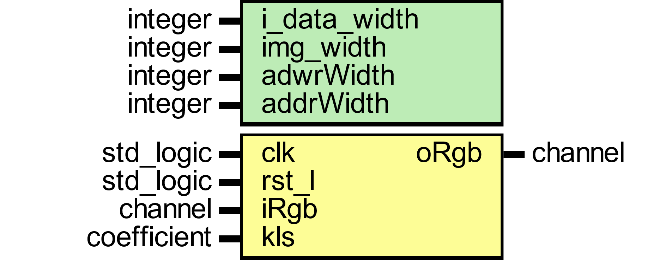

Figure

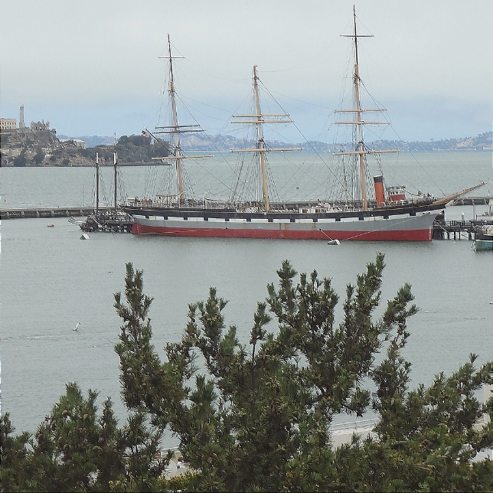

Blur Filter

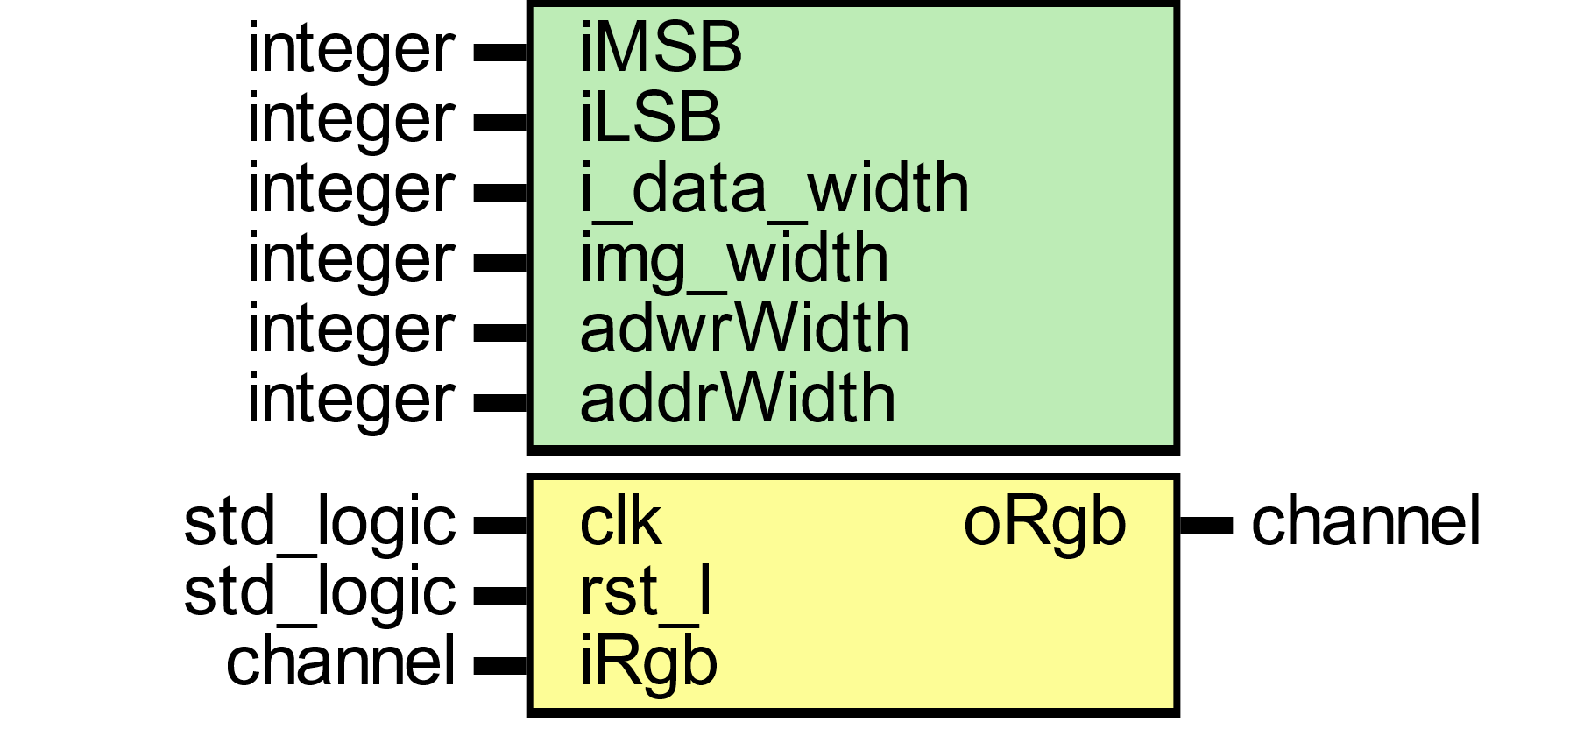

Figure

|  |  |  |  |
| --- | --- | --- | --- |
| Gray Level Colors | | | |
| 0.400 | 0.350 | 0.200 | 0.950 |
| 0.200 | 0.700 | 0.100 | 1.00 |
| 0.05 | 0.100 | 0.900 | 1.05 |
| 0.605 | 1.15 | 1.20 | **∑** |

Emboss Filter

An emboss filter will take video frame and convert into an embossed image.

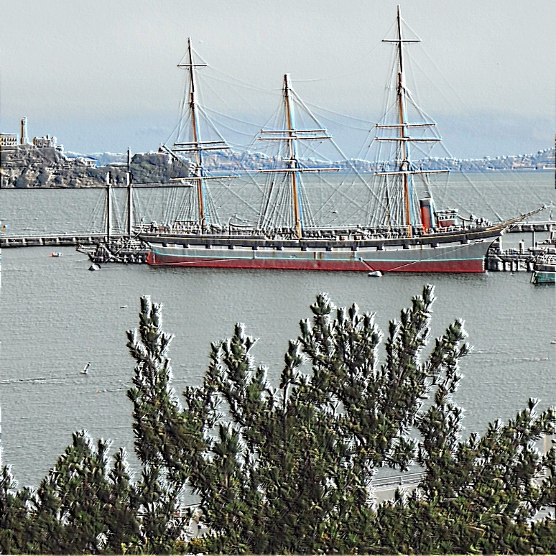

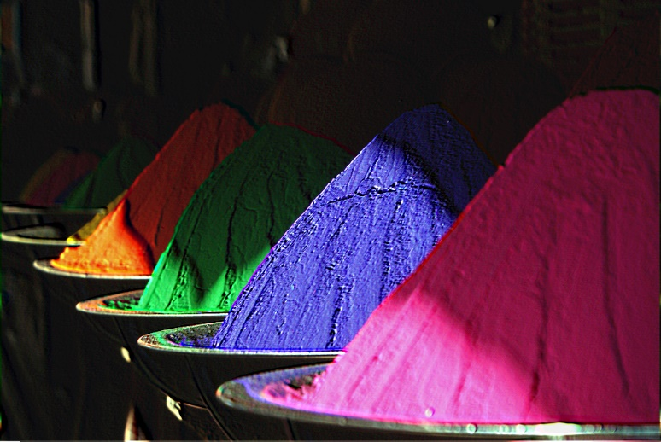

Sobel Filter

A Sobel filter will take video frame and convert into an Sobel image.

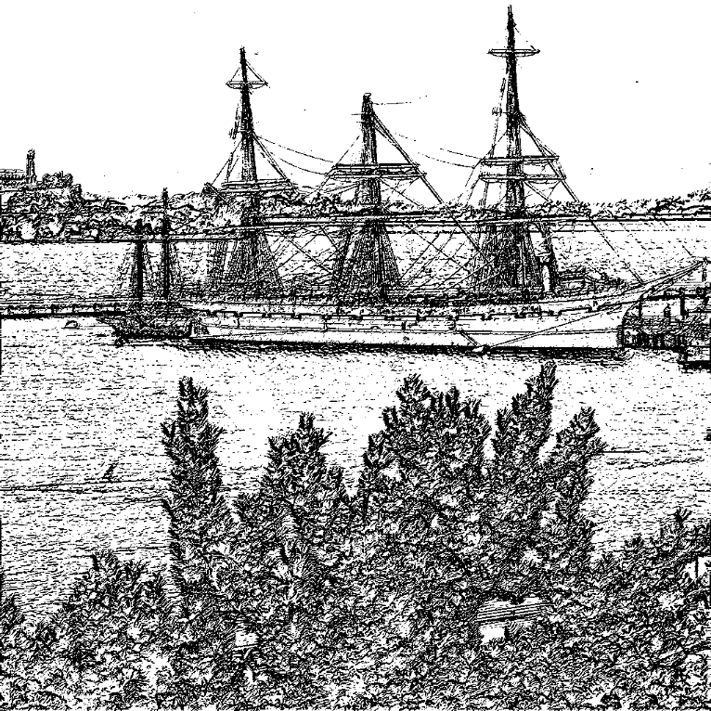

YCbCr Color Space

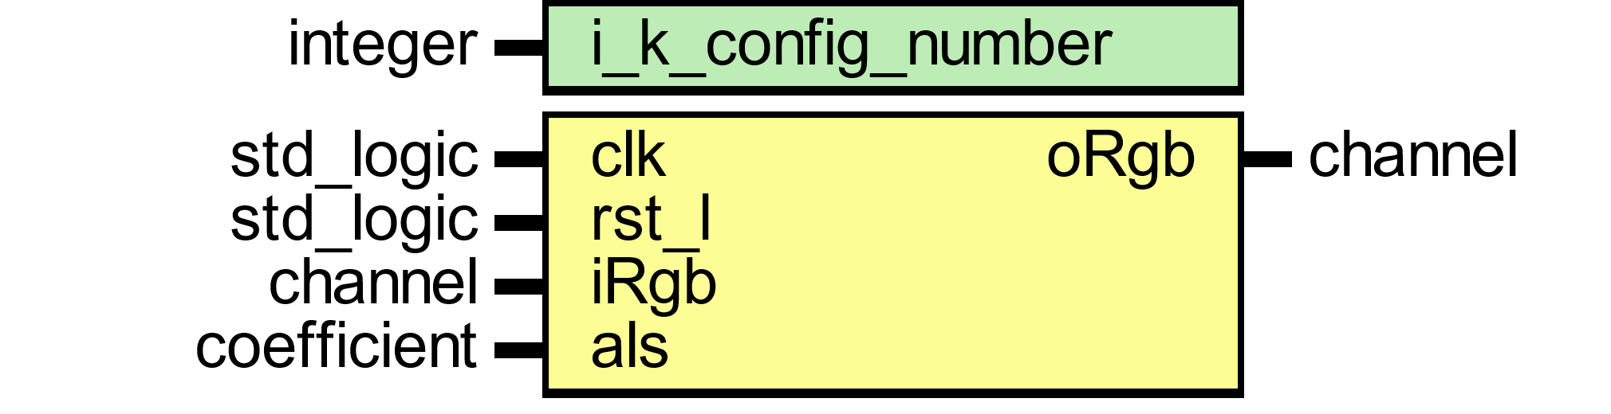

Figure 129

Color Adjust Matrix



Figure

The objective of the color adjust matrix is to transform each pixel red, green and blue channel into improve suitable agreement in display and light sources sensitivity. The color adjust matrix can eb expressed as a 3x3 matrix as in equation below. The ‘CAM’ is used to denote the color adjust matrix rgb values.

$$\left[\begin{matrix}R_{CAM} \\ G_{CAM} \\ B_{CAM}\end{matrix}\right]=\left[\begin{matrix}K1 & K2 & K3 \\ K4 & K5 & K6 \\ K7 & K8 & K9\end{matrix}\right]\left[\begin{matrix}R \\ G \\ B\end{matrix}\right]$$

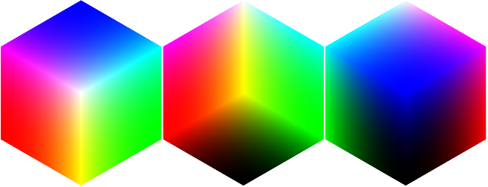

|  |  |  |  |  |
| --- | --- | --- | --- | --- |
| Color Adjust Matrix | | | | |
| CAM-1 | 5.000 | -3. 313 | -1. 687 | 0.00 |
| -1. 687 | 5.000 | -3. 313 | 0.00 |
| -3. 313 | -1. 687 | 5.000 | 0.00 |
| 0.00 | 0.00 | 0.00 |  |
| CAM-2 | 1.200 | -0.435 | -0.165 | 0.600 |
| -0.165 | 1.200 | -0.435 | 0.600 |
| -0.435 | -0.165 | 1.200 | 0.600 |
| 0.600 | 0.600 | 0.600 |  |
| CAM-3 | 0.900 | 0.300 | 0.350 | 1.650 |
| 0.350 | 0.900 | 0.300 | 1.650 |
| 0.300 | 0.350 | 0.900 | 1.650 |
| 1.650 | 1.650 | 1.650 |  |

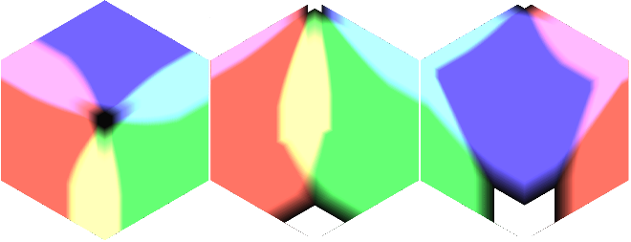

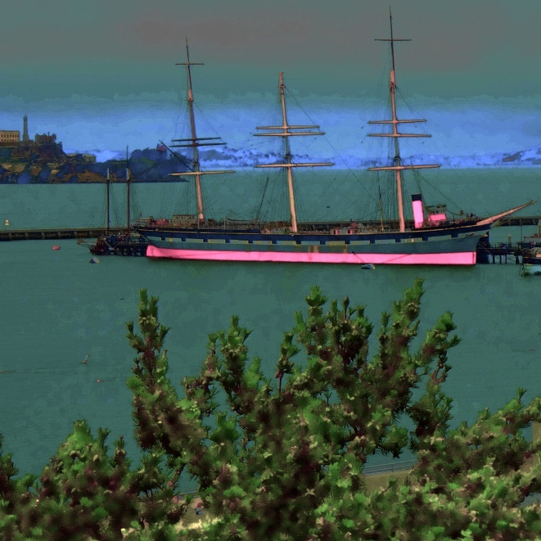

|  |  |  |  |  |
| --- | --- | --- | --- | --- |
| Color Adjust Matrix | | | | |
| CAM-1 | 1.340 | -0.850 | -0.400 | 0.09 |
| -0.400 | 1.340 | -0.850 | 0.09 |
| -0.850 | -0.400 | 1.340 | 0.09 |
| 0.09 | 0.09 | 0.09 |  |
| CAM-2 | 2.000 | -0.200 | -0.100 | 1.70 |
| -0.100 | 2.000 | -0.200 | 1.70 |
| -0.200 | -0.100 | 2.000 | 1.70 |
| 1.70 | 1.70 | 1.70 |  |
| CAM-3 | 1.5 | 0.900 | 0.650 | 3.05 |
| 0.650 | 1.5 | 0.900 | 3.05 |
| 0.900 | 0.650 | 1.5 | 3.05 |
| 3.05 | 3.05 | 3.05 |  |

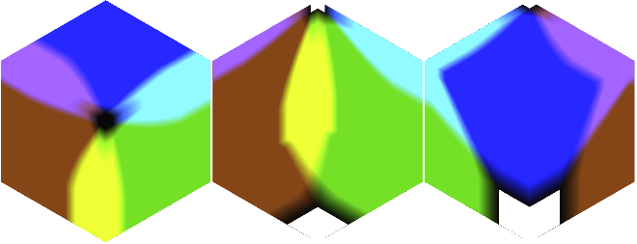

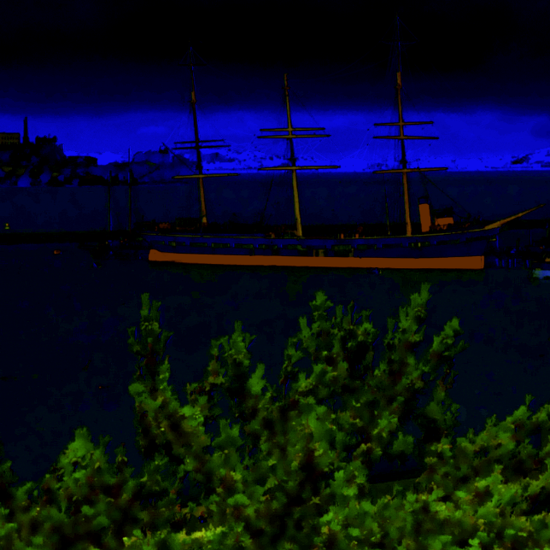

|  |  |  |  |  |
| --- | --- | --- | --- | --- |
| Color Adjust Matrix | | | | |
| CAM-1 | 1.5 | -0.250 | -0.250 | 1.00 |
| -0.250 | 1.5 | -0.250 | 1.00 |
| -0.250 | -0.250 | 1.5 | 1.00 |
| 1.00 | 1.00 | 1.00 |  |
| CAM-2 | 1.5 | -0.250 | -0.250 | 1.00 |
| -0.250 | 1.5 | -0.250 | 1.00 |
| -0.250 | -0.250 | 1.5 | 1.00 |
| 1.00 | 1.00 | 1.00 |  |
| CAM-3 | 1.5 | -0.250 | -0.250 | 1.00 |
| -0.250 | 1.5 | -0.250 | 1.00 |
| -0.250 | -0.250 | 1.5 | 1.00 |
| 1.00 | 1.00 | 1.00 |  |

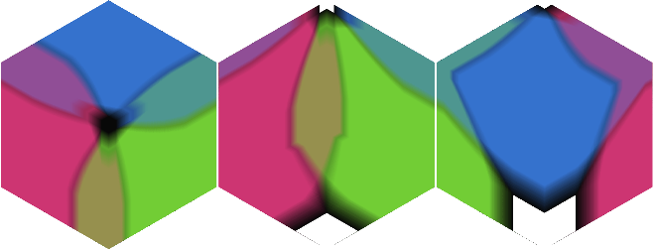

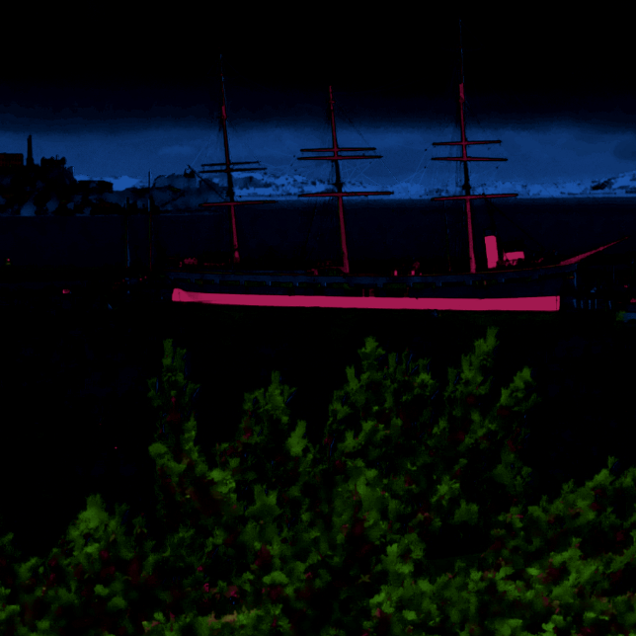

|  |  |  |  |  |
| --- | --- | --- | --- | --- |
| Color Adjust Matrix | | | | |
| CAM-1 | 1.5 | -0.250 | -0.250 | 1.00 |
| -0.250 | 1.5 | -0.250 | 1.00 |
| -0.250 | -0.250 | 1.5 | 1.00 |
| 1.00 | 1.00 | 1.00 |  |
| CAM-2 | 1.5 | -0.250 | -0.250 | 1.00 |
| -0.250 | 1.5 | -0.250 | 1.00 |
| -0.250 | -0.250 | 1.5 | 1.00 |
| 1.00 | 1.00 | 1.00 |  |
| CAM-3 | 1.5 | -0.250 | -0.250 | 1.00 |
| -0.250 | 1.5 | -0.250 | 1.00 |
| -0.250 | -0.250 | 1.5 | 1.00 |
| 1.00 | 1.00 | 1.00 |  |

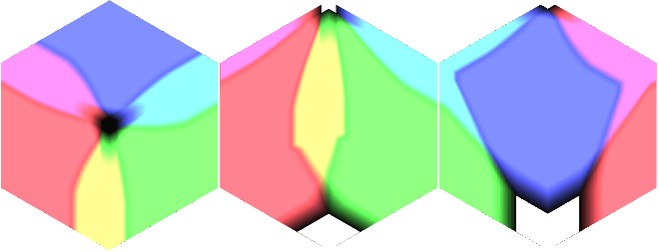

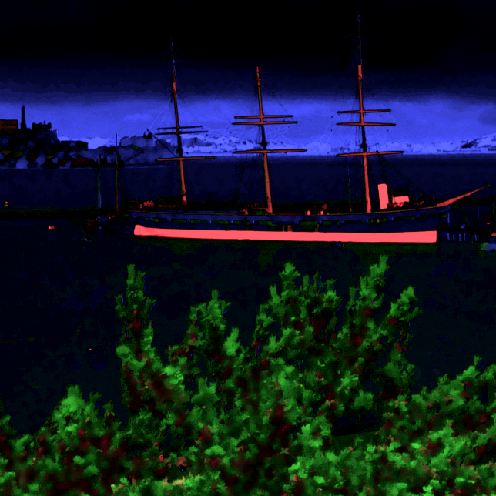

|  |  |  |  |  |
| --- | --- | --- | --- | --- |
| Color Adjust Matrix | | | | |
| CAM-1 | 1.5 | -0.250 | -0.250 | 1.00 |
| -0.250 | 1.5 | -0.250 | 1.00 |
| -0.250 | -0.250 | 1.5 | 1.00 |
| 1.00 | 1.00 | 1.00 |  |
| CAM-2 | 1.5 | -0.250 | -0.250 | 1.00 |
| -0.250 | 1.5 | -0.250 | 1.00 |
| -0.250 | -0.250 | 1.5 | 1.00 |
| 1.00 | 1.00 | 1.00 |  |
| CAM-3 | 1.5 | -0.250 | -0.250 | 1.00 |
| -0.250 | 1.5 | -0.250 | 1.00 |
| -0.250 | -0.250 | 1.5 | 1.00 |
| 1.00 | 1.00 | 1.00 |  |

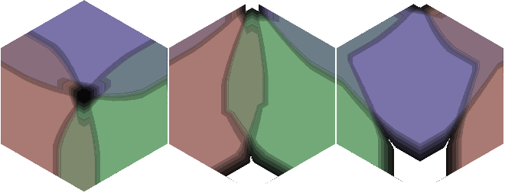

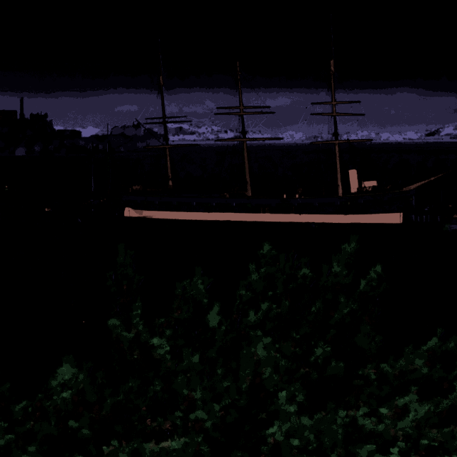

|  |  |  |  |  |
| --- | --- | --- | --- | --- |
| Color Adjust Matrix | | | | |
| CAM-1 | 1.5 | -0.250 | -0.250 | 1.00 |
| -0.250 | 1.5 | -0.250 | 1.00 |
| -0.250 | -0.250 | 1.5 | 1.00 |
| 1.00 | 1.00 | 1.00 |  |
| CAM-2 | 1.5 | -0.250 | -0.250 | 1.00 |
| -0.250 | 1.5 | -0.250 | 1.00 |
| -0.250 | -0.250 | 1.5 | 1.00 |
| 1.00 | 1.00 | 1.00 |  |
| CAM-3 | 1.5 | -0.250 | -0.250 | 1.00 |
| -0.250 | 1.5 | -0.250 | 1.00 |
| -0.250 | -0.250 | 1.5 | 1.00 |
| 1.00 | 1.00 | 1.00 |  |

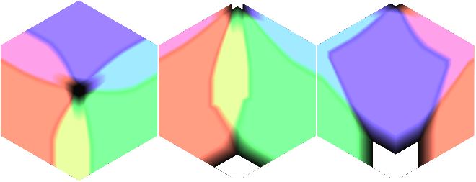

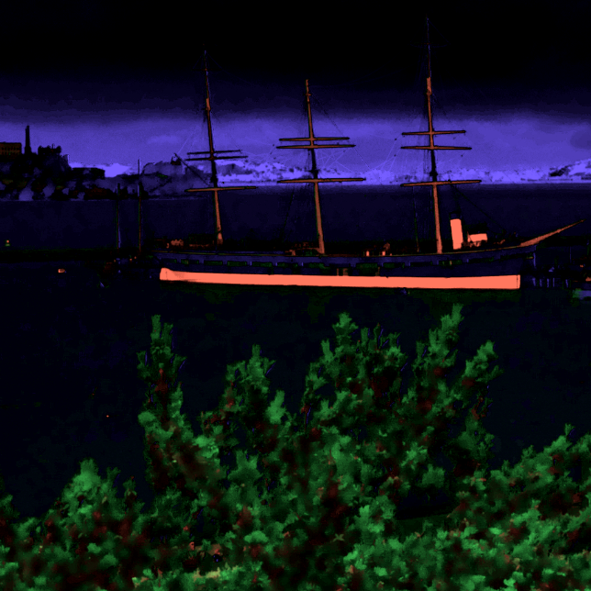

|  |  |  |  |  |
| --- | --- | --- | --- | --- |
| Color Adjust Matrix | | | | |
| CAM-1 | 1.5 | -0.250 | -0.250 | 1.00 |
| -0.250 | 1.5 | -0.250 | 1.00 |
| -0.250 | -0.250 | 1.5 | 1.00 |
| 1.00 | 1.00 | 1.00 |  |
| CAM-2 | 1.5 | -0.250 | -0.250 | 1.00 |
| -0.250 | 1.5 | -0.250 | 1.00 |
| -0.250 | -0.250 | 1.5 | 1.00 |
| 1.00 | 1.00 | 1.00 |  |
| CAM-3 | 1.5 | -0.250 | -0.250 | 1.00 |
| -0.250 | 1.5 | -0.250 | 1.00 |
| -0.250 | -0.250 | 1.5 | 1.00 |
| 1.00 | 1.00 | 1.00 |  |

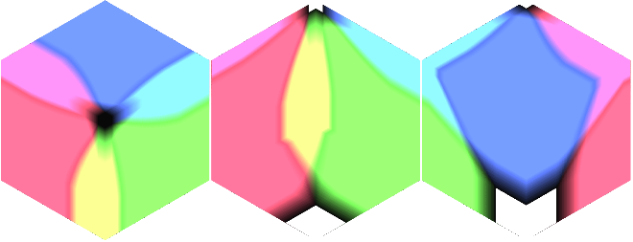

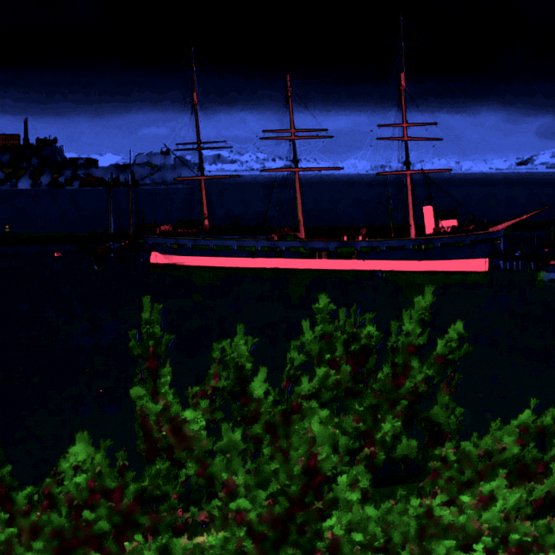

|  |  |  |  |  |
| --- | --- | --- | --- | --- |
| Color Adjust Matrix | | | | |
| CAM-1 | 1.250 | -0.850 | -0.400 | 0.00 |
| -0.400 | 1.250 | -0.850 | 0.00 |
| -0.850 | -0.400 | 1.250 | 0.00 |
| 0.00 | 0.00 | 0.00 |  |
| CAM-2 | 1.00 | -0.600 | -0.400 | 0.00 |
| -0.400 | 1.00 | -0.600 | 0.00 |
| -0.600 | -0.400 | 1.00 | 0.00 |
| 0.00 | 0.00 | 0.00 |  |
| CAM-3 | 1.5 | 1.200 | 0.500 | 3.20 |
| 0.500 | 1.5 | 1.200 | 3.20 |
| 1.200 | 0.500 | 1.5 | 3.20 |
| 3.20 | 3.20 | 3.20 |  |

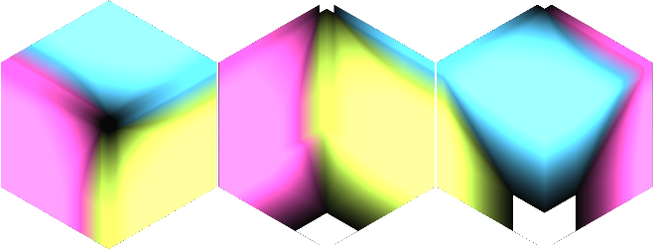

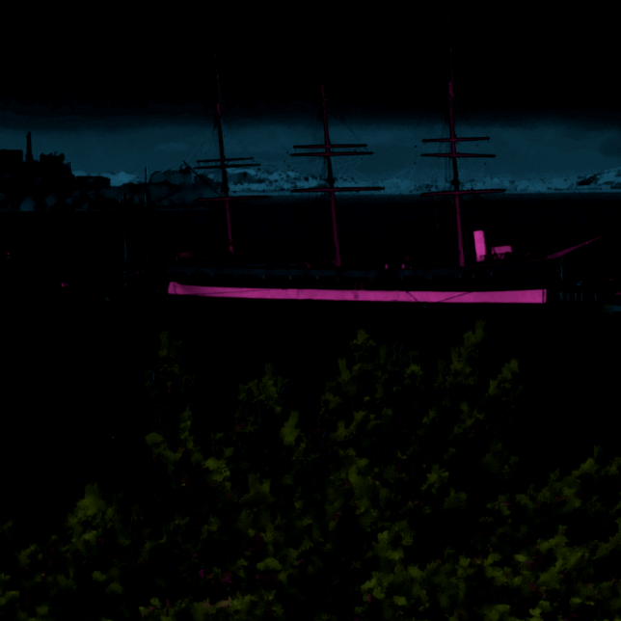



Local Dynamic Threshold Segmentation

This module takes the pixel as the center and check its neighboring pixels and compared with one by one. If the difference level is within the threshold limits than merge it and the new pixel value will be compared with each neighborhood pixels. The produced new region is uniform and difference in region would be small.

IMAGE CONTRAST AND BRIGHTNESS

Camera Raw Data

This module read raw bayer filter mosaic format 12-bit data from d5m camera. External Pixel clock is from camera used to sample 1 pixel which equal to 1 pll generated master external clock. Host camera data is than stored into buffer line by line which is ready to be fetch at system clock rate. Input line and frame valid signals are used to start reading stored buffer data. Valid read is enabled when both frame and line valid signal are asserted high. Buffer size set to be the size of frame width. The read controller side reads whole frame width from the buffer. Values written to buffer run at pixel clock rate whereas buffer read side run at faster rate than pixel clock.

Buffersize is auto size supported which is controlled by input line valid from host camera and maximum is set to default value of 3071. A base configuration consisting of a single 24-bits pipeline, capable of processing 1080p HD video at 30 frames per second.

Input data from camera is color filtered which is arranged in a bayer patten. Input data is read with line-by-line transfer rate of pixel clock which later synchronize into system clock.

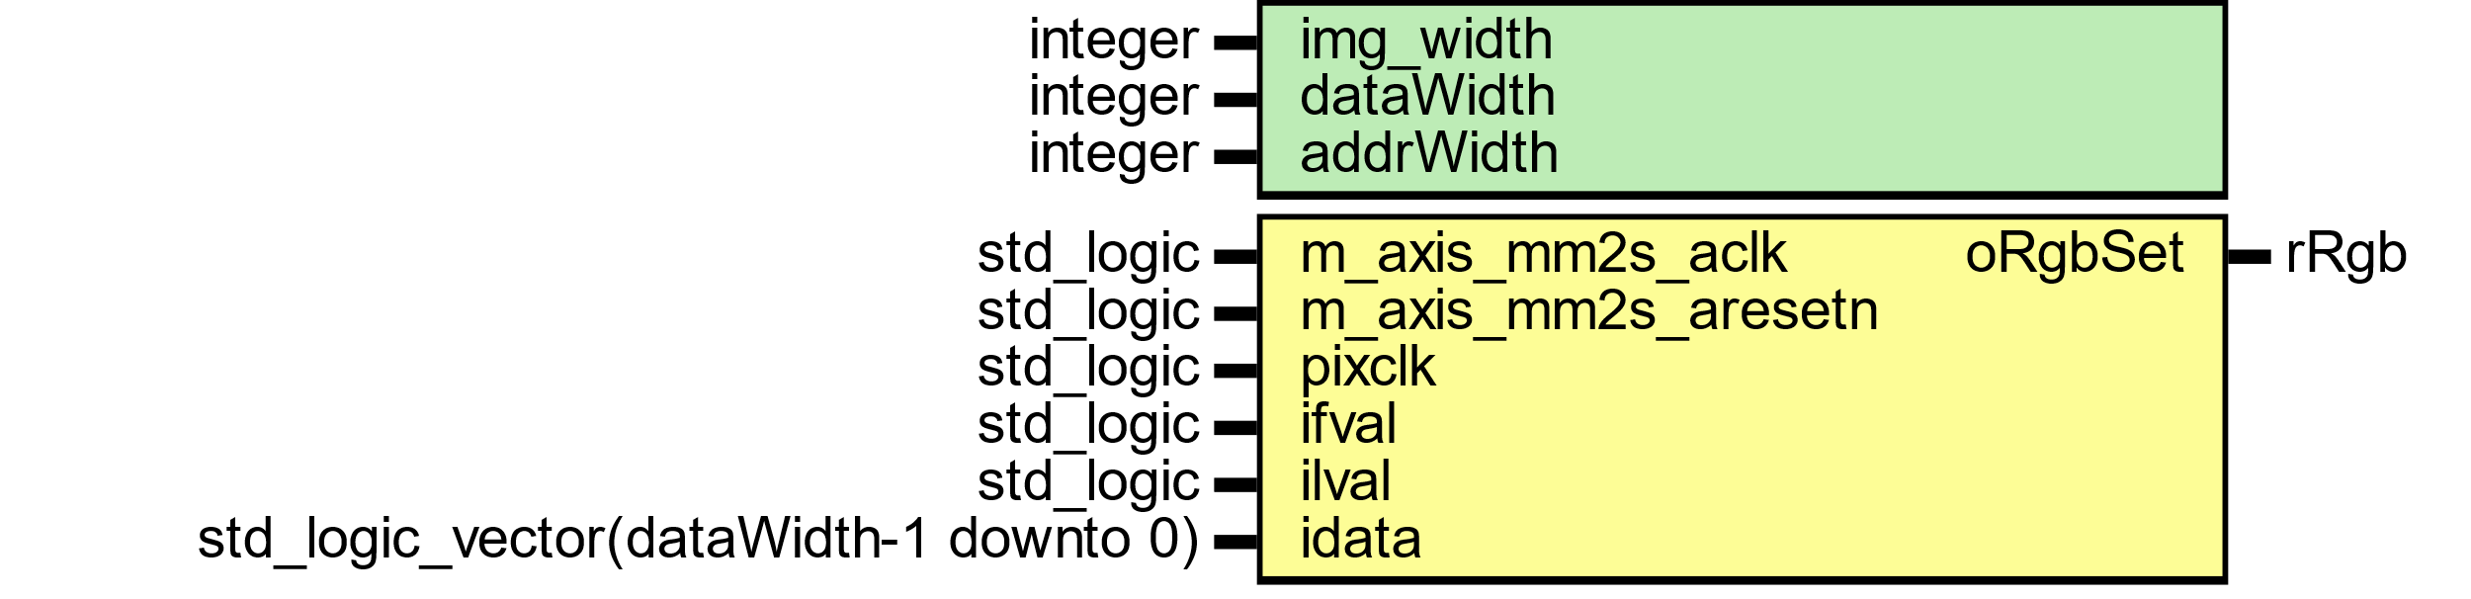

Figure : camera raw data module

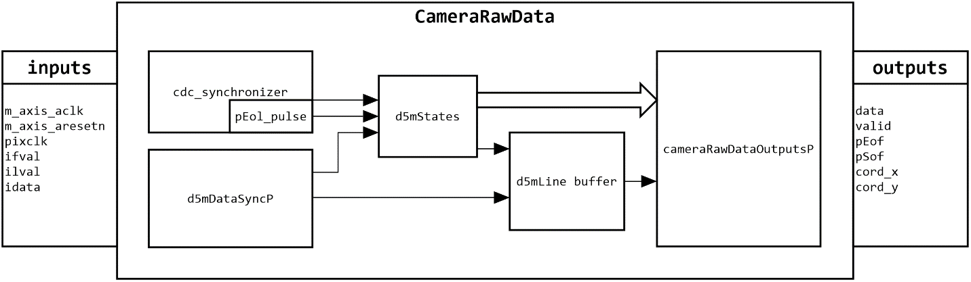

Figure : General view of camera raw data flow

Host camera interface uses 12 bits parallel input data with line and frame valid control signals.

Image Read Interface

Figure

Image processed are shown below using ccm1.

Three Taps data



Figure

Four Taps data



Figure

Pixel Coordinates



Figure





Figure



Figure

Camera Raw Data

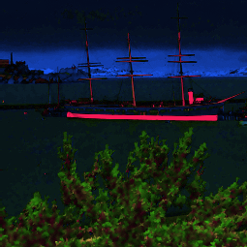

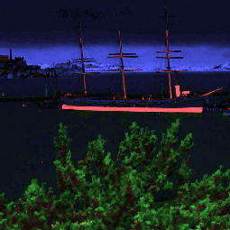

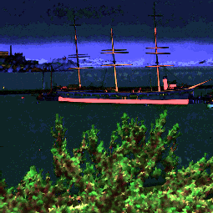

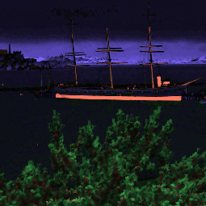

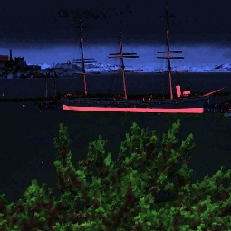

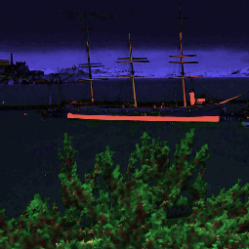

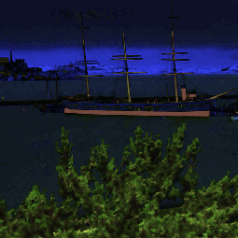

Histogram

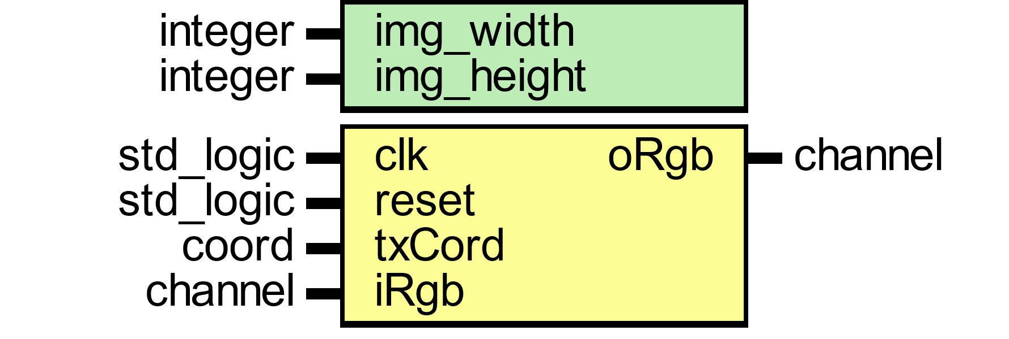

This module assigns memory location as rgb red channel input integer between 0 to 255 which equally 8 bits to express 256 levels address. Every input value would accumulate to its location to show how many hits per level.



Figure

Histogram Equation

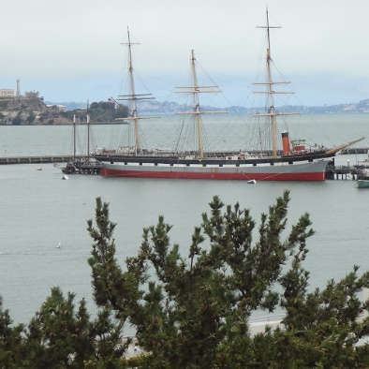

|  |  |  |  |
| --- | --- | --- | --- |
|  |  |  |  |
| 1ST figure shows rgb image. 2nd figure shows red channel. 3rd figure shows green channel and 4th figure shows blue channel. | | | |

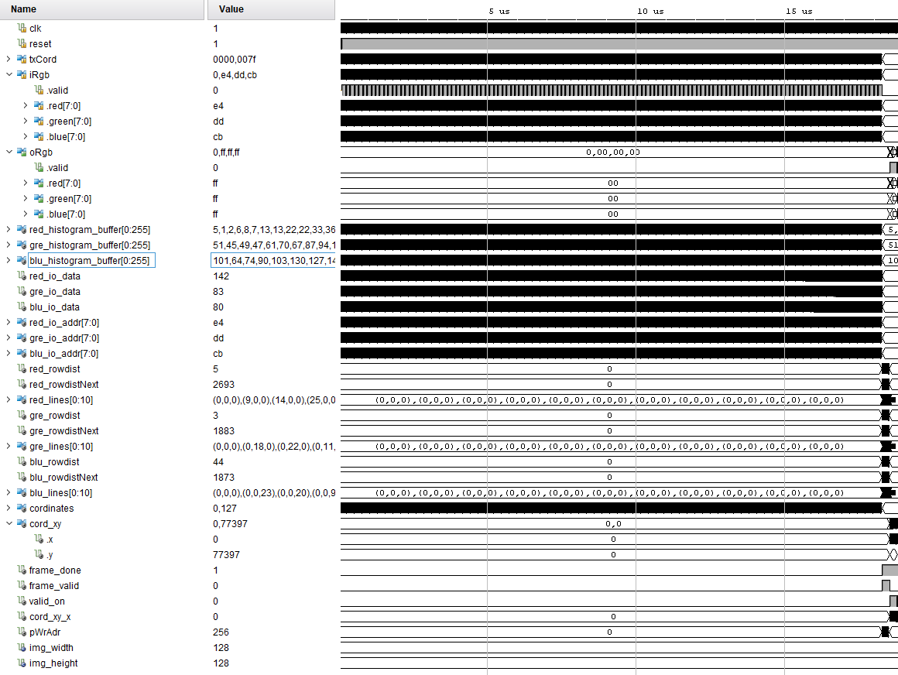

Figure

TESTBENCH COMPONENTS/OBJECTS

UVM testbench build from classes. Test has environment, the environment has d5m agent.

Flow of testbench is to connect DUT and testbench, configure d5m agent, generate stimulus.

In the filter’s generic package, a common verification scenario for vfp tests is to initialize set of parameters by setting to define enable variable in frame enable package. This type of initialization can be done at terminal during compilation unit scope. In table shows available define variable with available size for image testing.

|  |  |  |
| --- | --- | --- |
| `define | size | description |
| rgb | **0**=64x64,  **1**=128x125,  **2**=255x255,  **3**=1920x1080 |  |
| sharp |  |
| blur |  |
| embross |  |
| hsl |  |
| hsv |  |
| cgain |  |
| sobel |  |

Set of parameters for image filter type and their size are assigned for current test values as shown in table 2 via defined macro in frame enable package according to table 1.

|  |  |  |
| --- | --- | --- |
| parameter | value | description |
| F_CGA | 1/0 | Enable ‘1’ Cgain color adjust for test. |
| F_SHP | 1/0 | Enable ‘1’ Sharp Filter for test. |
| F_BLU | 1/0 | Enable ‘1’ Blure Filter for test. |
| F_HSL | 1/0 | Enable ‘1’ HSL color space for test. |
| F_HSV | 1/0 | Enable ‘1’ HSV color space for test. |
| F_RGB | 1/0 | Enable ‘1’ RGB color space for test. |
| F_SOB | 1/0 | Enable ‘1’ Sobel filter for test. |
| F_EMB | 1/0 | Enable ‘1’ Embross Filter for test. |

For axi4-lite module registers in rtl, following parameters offset for base address are set for axi4 lite transections as shown table below.

|  |  |  |
| --- | --- | --- |
| Register Name | Offet | Description |
| initAddr | 8'h00 |  |
| oRgbOsharp | 8'h00 |  |
| oEdgeType | 8'h04 |  |
| filter_id | 8'h08 |  |
| aBusSelect | 8'h0C |  |
| threshold | 8'h10 |  |
| videoChannel | 8'h14 |  |
| dChannel | 8'h18 |  |
| cChannel | 8'h1C |  |
| kls_k1 | 8'h20 |  |
| kls_k2 | 8'h24 |  |
| kls_k3 | 8'h28 |  |
| kls_k4 | 8'h2C |  |
| kls_k5 | 8'h30 |  |
| kls_k6 | 8'h34 |  |
| kls_k7 | 8'h38 |  |
| kls_k8 | 8'h3C |  |
| kls_k9 | 8'h40 |  |
| kls_config | 8'h44 |  |
| als_k1 | 8'h54 |  |
| als_k2 | 8'h58 |  |
| als_k3 | 8'h5C |  |
| als_k4 | 8'h60 |  |
| als_k5 | 8'h64 |  |
| als_k6 | 8'h68 |  |
| als_k7 | 8'h6C |  |
| als_k8 | 8'h70 |  |
| als_k9 | 8'h74 |  |
| als_config | 8'h78 |  |
| pReg_pointInterest | 8'h7C |  |
| pReg_deltaConfig | 8'h80 |  |
| pReg_cpuAckGoAgain | 8'h84 |  |
| pReg_cpuWgridLock | 8'h88 |  |
| pReg_cpuAckoffFrame | 8'h8C |  |
| pReg_fifoReadAddress | 8'h90 |  |
| pReg_clearFifoData | 8'h94 |  |
| rgbCoord_rl | 8'hC8 |  |
| rgbCoord_rh | 8'hCC |  |
| rgbCoord_gl | 8'hD0 |  |
| rgbCoord_gh | 8'hD4 |  |
| rgbCoord_bl | 8'hD8 |  |
| rgbCoord_bh | 8'hDC |  |
| oLumTh | 8'hE0 |  |
| oHsvPerCh | 8'hE4 |  |
| oYccPerCh | 8'hE8 |  |

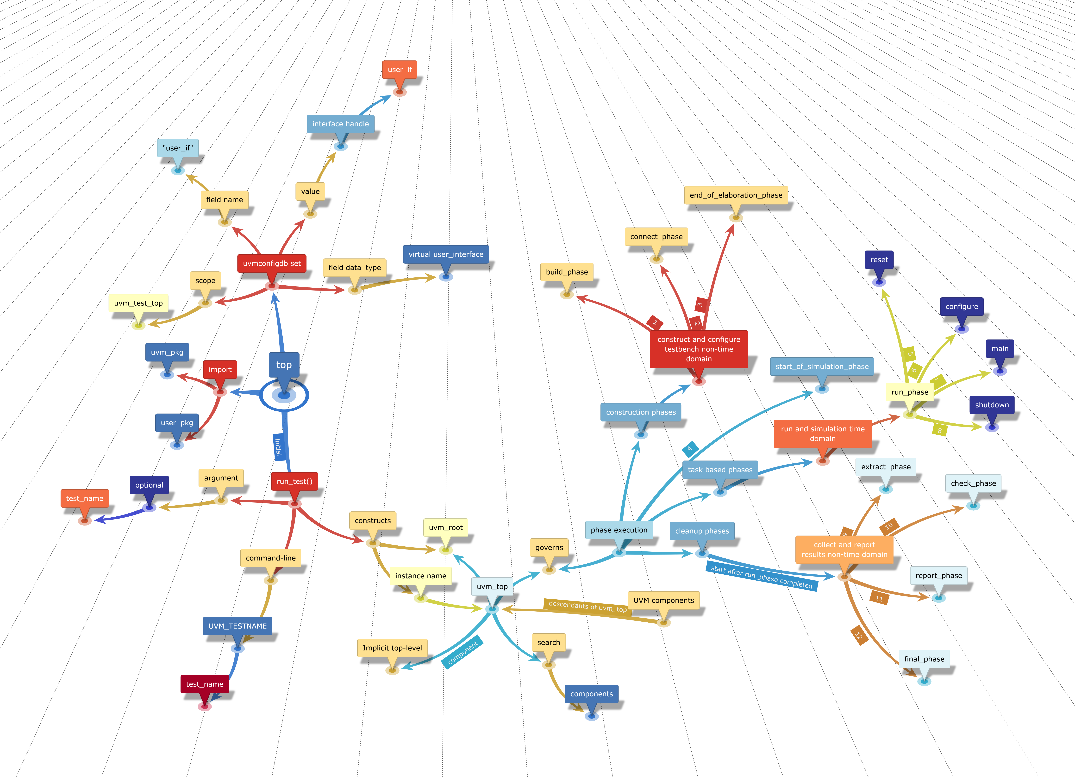

Figure 141

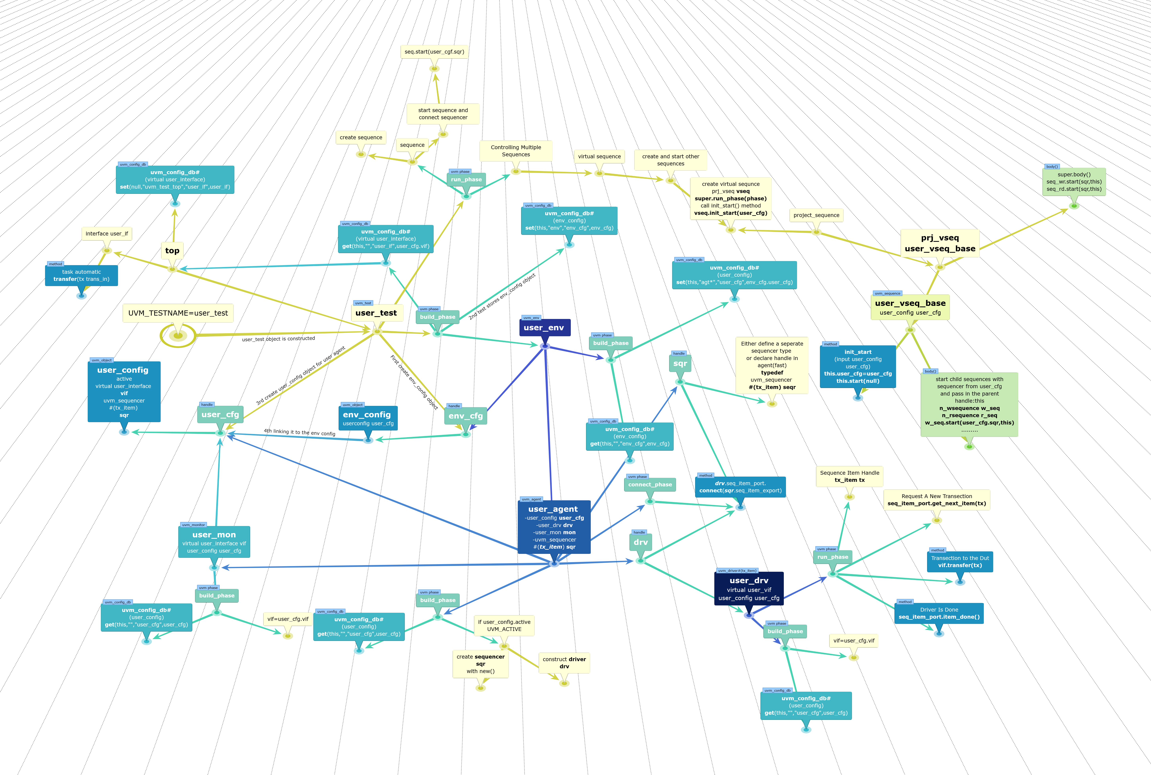

Figure 142

dut cONNECTIONS

Input protocol interface

Output protocol interface

SEQUENCE ITEM

SEQUENCE

SEQUENCER

DRIVER

This class which extended from uvm driver pull data items generated by a sequencer and drive it to the DUT. In run phase, methods are used for reading and writing operation to dut through dut interface handle.

Axi4lite communication flow across 5 parallel channels. Read transection phases split into 2 phases. Request on read address channel and response on read data channel. Write transection split into 3 phases: address, data and response with the status. Multiple read and write transaction are concurrent. Write address transfer can come before, during, or after the write data. Signal for read address channels start with AR* and read data signals start with R*. Write address signal start with AW*, write data signal name start with W* and write response start with B*. Axi4lite has flow control on each channel to control the rate the information is exchange such as address, data and response. The source generates valid to indicate information is available. Destination generates ready signal to accept the information. The source assert valid first and wait for destination to be ready and then transfer the info. Or destination could go first, asserting ready to receive and wait for the source. When source is ready, it asserts valid and transfer the info. The transfer only occurs when both valid and ready are high.

Basic overview:

1. Declare the virtual interface.
2. Get the interface handle using get config_db.
3. Add the get config_db in the build_phase.
4. Add driving logic. get the seq_item and drive to dut signals.

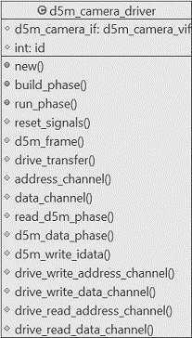

Figure

**DECLARATION:**

This uvm driver class is derived from uvm component.

|  |
| --- |
| class d5m_camera_driver extends uvm_driver #(d5m_trans); |

**DATA MEMEBERS**

|  |
| --- |
| *protected virtual d5m_camera_if d5m_camera_vif;*  *protected int id;* |

**NEW CONSTRUCT**

For Each component, the constructor must execute and complete in order to bring the component into existence. Therefore, new () must run before build() or any other subsequent phase can execute.

|  |
| --- |
| *function new (string name, uvm_component parent);*  *super.new(name, parent);*  *endfunction: new* |

**BUILD_PHASE**

Build method run top-down and the rest of the phases run bottom-up. In this phase, config the dut interface handle through get method. The uvm_config_db parameterized class provides a convenience interface on top of uvm_resource_db is used to for reading resource database. The uvm_config_db is derived from uvm_resource_db class. Get value of field_name “d5m_camera_vif”, using component cntxt ”this” as starting search point.

|  |
| --- |
| *function void build_phase (uvm_phase phase);*  *super.build_phase(phase);*  *if (!uvm_config_db#(virtual d5m_camera_if)::get*  *(this, "", "d5m_camera_vif", d5m_camera_vif))*  *`uvm_fatal("NOVIF", {"virtual interface must be set for:*  *",get_full_name(), ".d5m_camera_vif"});*  *endfunction: build_phase* |

**RUN_PHASE**

In this method, fork join constructs are used to separate threads that drive each of the channels.

|  |
| --- |
| *virtual task run_phase (uvm_phase phase);*  *fork*  *reset signals();*  *d5m_frame();*  *join*  *endtask: run_phase* |

**RESET SIGNALS**

Reset the dut axi4 lite and d5m_cam_mod input signals when system reset is asserted from low to high.

|  |
| --- |
| *virtual protected task reset_signals();*  *forever begin*  *@(posedge d5m_camera_vif.ARESETN);*  *d5m_camera_vif.axi4.AWADDR <= 8'h0;*  *d5m_camera_vif.axi4.AWPROT <= 3'h0;*  *d5m_camera_vif.axi4.AWVALID <= 1'b0;*  *d5m_camera_vif.axi4.WDATA <= 32'h0;*  *d5m_camera_vif.axi4.WSTRB <= 4'h0;*  *d5m_camera_vif.axi4.WVALID <= 1'b0;*  *d5m_camera_vif.axi4.BREADY <= 1'b0;*  *d5m_camera_vif.axi4.ARADDR <= 8'h0;*  *d5m_camera_vif.axi4.ARPROT <= 3'h0;*  *d5m_camera_vif.axi4.ARVALID <= 1'b0;*  *d5m_camera_vif.axi4.RREADY <= 1'b0;*  *d5m_camera_vif.d5p.iImageTypeTest <= 1'b0;*  *d5m_camera_vif.d5p.iReadyToRead <= 1'b0;*  *d5m_camera_vif.d5p.fvalid <= 1'b0;*  *d5m_camera_vif.d5p.lvalid <= 1'b0;*  *end*  *endtask: reset_signals* |

**D5M FRAME**

In this method, drive the signals from defined seq in uvm_sequence.

|  |
| --- |
| *virtual protected task d5m_frame();*  *forever begin*  *@(posedge d5m_camera_vif.clkmm);*  *seq_item_port.get_next_item(req);*  *drive_transfer(req);*  *seq_item_port.item_done();*  *end*  *endtask: d5m_frame* |

**DRIVE TRANSFER**

This method which is master to dut axi4lite interface write/read data at given address using bus handshaking protocol. First valid address is transmitted and then wait for valid response in given time of 61 clock cycles in axi4_address method. Timeout accord on 62 clock cycle, if no response is asserted high on bvalid signal from dut and timeout is flagged using uvm_error macro. If valid response is asserted then axi4_data method write/read data depending on case statement. Once axi4 bus config the video process module in dut then write/read operation can be initiated by calling the d5m_pixel method.

|  |
| --- |
| *virtual protected task drive_transfer (d5m_trans d5m_tx);*  *axi4_address(d5m_tx);*  *axi4_data(d5m_tx);*  *d5m_pixel(d5m_tx);*  *endtask: drive_transfer* |

**AXI4 ADDRESS CHANNEL**

In this method, write/read axi4 address channel.

|  |
| --- |
| *virtual protected task axi4_address (d5m_trans d5m_tx);*  *case (d5m_tx.d5m_txn)*  *AXI4_WRITE : axi4_write_address(d5m_tx);*  *AXI4_READ : axi4_wread_address(d5m_tx)*  *endcase*  *endtask: axi4_address* |

**AXI4 DATA CHANNEL**

In this method, write/read axi4 data channel through axi4_write data and axi4_read_data methods on selected case.

|  |
| --- |
| *virtual protected task axi4_data (d5m_trans d5m_tx);*  *bit[31:0] rw_data;*  *bit err;*  *rw_data = d5m_tx.axi4_lite.data;*  *case (d5m_tx.d5m_txn)*  *AXI4_WRITE : axi4_write_data(d5m_tx);*  *AXI4_READ : axi4_read_data(rw_data, err);*  *endcase*  *endtask: axi4_data* |

**D5M PIXEL**

In this method, d5m read/write frame rgb pixel per transaction.

|  |
| --- |
| *virtual protected task d5m_pixel (d5m_trans d5m_tx);*  *case (d5m_tx.d5m_txn)*  *D5M_WRITE : d5m_write_pixel_data(d5m_tx);*  *IMAGE_READ : d5m_read_pixel_data(d5m_tx);*  *endcase*  *endtask: d5m_pixel* |

**D5M WRITE PIXEL DATA**

In this method, write data to d5m camera mod from d5m_trans sequence.

|  |
| --- |
| virtual protected task d5m_write_pixel_data (d5m_trans d5m_tx);  d5m_camera_vif.d5p.iReadyToRead <= 1'b0;  d5m_camera_vif.d5p.iImageTypeTest <= d5m_tx.d5p.iImageTypeTest;  d5m_camera_vif.d5p.rgb <= d5m_tx.d5p.rgb;  d5m_camera_vif.d5p.fvalid <= d5m_tx.d5p.fvalid;  d5m_camera_vif.d5p.lvalid <= d5m_tx.d5p.lvalid;  endtask: d5m_write_pixel_data |

**D5M READ PIXEL DATA**

In this method, config test type during read operation and wait for end of frame pulse.

|  |
| --- |
| *virtual protected task d5m_read_pixel_data(d5m_trans d5m_tx);*  *@(posedge d5m_camera_vif.clkmm);*  *d5m_camera_vif.d5p.iImageTypeTest <= 1'b0;*  *d5m_camera_vif.d5p.iReadyToRead <= 1'b1;*  *forever begin*  *@(posedge d5m_camera_vif.clkmm);*  *if (d5m_camera_vif.d5m.eof) break;*  *end*  *endtask: d5m_read_pixel_data* |

**AXI4 WRITE ADDRESS**

In this method, write address and assert write valid high and then wait for response from dut BVALID signal within 62 clock cycles.

|  |
| --- |
| *virtual protected task axi4_write_address (d5m_trans d5m_tx);*  *int axi_lite_ctr;*  *d5m_camera_vif.axi4.AWADDR <= {8'h0, d5m_tx.axi4_lite.addr};*  *d5m_camera_vif.axi4.AWPROT <= 3'h0;*  *d5m_camera_vif.axi4.AWVALID <= 1'b1;*  *// wait for write response*  *for(axi_lite_ctr = 0; axi_lite_ctr <= 62; axi_lite_ctr ++) begin*  *@(posedge d5m_camera_vif.clkmm);*  *if (d5m_camera_vif.axi4.BVALID) break;*  *end*  *if (axi_lite_ctr == 62) begin*  *`uvm_error("axi_lite_master_driver","AWVALID timeout");*  *end*  *endtask: axi4_write_address* |

**AXI4 WRITE DATA**

|  |
| --- |
| *virtual protected task axi4_write_data (d5m_trans d5m_tx);*  *int axi_lite_ctr;*  *d5m_camera_vif.axi4.WDATA <= d5m_tx.axi4_lite.data;*  *d5m_camera_vif.axi4.WSTRB <= 4'hf;*  *d5m_camera_vif.axi4.WVALID <= 1'b1;*  *@(posedge d5m_camera_vif.clkmm);*  *for(axi_lite_ctr = 0; axi_lite_ctr <= 62; axi_lite_ctr ++) begin*  *@(posedge d5m_camera_vif.clkmm);*  *if (d5m_camera_vif.axi4.WREADY)*  *d5m_camera_vif.axi4.AWADDR <= 8'h0;*  *d5m_camera_vif.axi4.AWPROT <= 3'h0;*  *d5m_camera_vif.axi4.AWVALID <= 1'b0;*  *break;*  *end*  *if (axi_lite_ctr == 62) begin*  *`uvm_error("axi_lite_master_driver","AWVALID timeout");*  *end*  *@(posedge d5m_camera_vif.clkmm);*  *d5m_camera_vif.axi4.WDATA <= 32'h0;*  *d5m_camera_vif.axi4.WSTRB <= 4'h0;*  *d5m_camera_vif.axi4.WVALID <= 1'b0;*  *// wait for write response*  *for(axi_lite_ctr = 0; axi_lite_ctr <= 62; axi_lite_ctr ++) begin*  *@(posedge d5m_camera_vif.clkmm);*  *if (d5m_camera_vif.axi4.BVALID) break;*  *end*  *if (axi_lite_ctr == 62) begin*  *`uvm_error("axi_lite_master_driver","BVALID timeout");*  *end*  *else begin*  *if (d5m_camera_vif.axi4.BVALID == 1'b1 && d5m_camera_vif.axi4.BRESP != 2'h0)*  *`uvm_error("axi_lite_master_driver","Received ERROR Write Response");*  *d5m_camera_vif.axi4.BREADY <= d5m_camera_vif.axi4.BVALID;*  *@(posedge d5m_camera_vif.clkmm);*  *end*  *endtask: axi4_write_data* |

**AXI4 WREAD ADDRESS**

|  |
| --- |
| *virtual protected task axi4_wread_address (d5m_trans d5m_tx);*  *int axi_lite_ctr;*  *d5m_camera_vif.axi4.ARADDR <= {8'h0, d5m_tx.axi4_lite.addr};*  *d5m_camera_vif.axi4.ARPROT <= 3'h0;*  *d5m_camera_vif.axi4.ARVALID <= 1'b1;*  *for(axi_lite_ctr = 0; axi_lite_ctr <= 62; axi_lite_ctr ++) begin*  *@(posedge d5m_camera_vif.clkmm);*  *if (d5m_camera_vif.axi4.ARREADY) break;*  *end*  *if (axi_lite_ctr == 62) begin*  *`uvm_error("axi_lite_master_driver","ARVALID timeout");*  *end*  *@(posedge d5m_camera_vif.clkmm);*  *d5m_camera_vif.axi4.ARADDR <= 8'h0;*  *d5m_camera_vif.axi4.ARPROT <= 3'h0;*  *d5m_camera_vif.axi4.ARVALID <= 1'b0;*  *endtask: axi4_wread_address* |

**AXI4 READ DATA**

In this method, axi4lite read data.

|  |
| --- |
| *virtual protected task axi4_read_data (output bit [31:0] data, output bit error);*  *int axi_lite_ctr;*  *for(axi_lite_ctr = 0; axi_lite_ctr <= 62; axi_lite_ctr ++) begin*  *@(posedge d5m_camera_vif.clkmm);*  *if (d5m_camera_vif.axi4.RVALID) break;*  *end*  *data = d5m_camera_vif.axi4.RDATA;*  *if (axi_lite_ctr == 62) begin*  *`uvm_error("axi_lite_master_driver","RVALID timeout");*  *end*  *else begin*  *if (d5m_camera_vif.axi4.RVALID == 1'b1 && d5m_camera_vif.axi4.RRESP != 2'h0)*  *`uvm_error("axi_lite_master_driver","Received ERROR Read Response");*  *d5m_camera_vif.axi4.RREADY <= d5m_camera_vif.axi4.RVALID;*  *@(posedge d5m_camera_vif.clkmm);*  *end*  *endtask: axi4_read_data* |

MONITOR

This class which extended from uvm_monitor.

Basic overview:

• Declare the virtual interface.

• Get the interface handle using get config_db.

**DECLARATION:**

This uvm_monitor class is derived from uvm component.

class d5m_mon_dut extends uvm_monitor;

**DATA MEMEBERS**

*protected virtual d5m_camera_if d5m_camera_vif;*

*protected int id;*

*uvm_analysis_port #(d5m_trans) mon_d5m_dut;*

**NEW CONSTRUCT**

For Each component, the constructor must execute and complete in order to bring the component into existence. Therefore, new () must run before build() or any other subsequent phase can execute.

*function new (string name, uvm_component parent);*

*super.new(name, parent);*

*endfunction: new*

**BUILD_PHASE**

In this phase, config the dut interface handle through get method. The uvm_config_db parameterized class provides a convenience interface on top of uvm_resource_db is used to for reading resource database. The uvm_config_db is derived from uvm_resource_db class. Get value of field_name “d5m_camera_vif”, using component cntxt ”this” as starting search point.

function void build_phase (uvm_phase phase);

super.build_phase(phase);

if(!uvm_config_db#(virtual d5m_camera_if)::get(this, "", "d5m_camera_vif", d5m_camera_vif))

`uvm_fatal("NOVIF",{"virtual interface must be set for: ",get_full_name(), ".d5m_camera_vif"});

mon_d5m_dut = new("mon_d5m_dut", this);

endfunction: build_phase

**RUN_PHASE**

In this method, call collection transection method.

**COLLECT_TRANSACTIONS**

*virtual protected task collect_transactions();*

*d5m_trans rx_fdut;*

*rx_fdut = d5m_trans::type_id::create("rx_fdut");*

*forever begin*

*@(posedge d5m_camera_vif.clkmm)*

*rx_fdut.d5m.valid = d5m_camera_vif.d5m.valid;*

*rx_fdut.d5m.red = d5m_camera_vif.d5m.red;*

*rx_fdut.d5m.green = d5m_camera_vif.d5m.green;*

*rx_fdut.d5m.blue = d5m_camera_vif.d5m.blue;*

*rx_fdut.d5m.rgb = d5m_camera_vif.d5m.rgb;*

*rx_fdut.d5m.lvalid = d5m_camera_vif.d5m.lvalid;*

*rx_fdut.d5m.fvalid = d5m_camera_vif.d5m.fvalid;*

*rx_fdut.d5m.x = d5m_camera_vif.d5m.x;*

*rx_fdut.d5m.y = d5m_camera_vif.d5m.y;*

*rx_fdut.d5m.eof = d5m_camera_vif.d5m.eof;*

*mon_d5m_dut.write(rx_fdut);*

*end*

*endtask: collect_transactions*

Tx monitor watches transection from dut. d5m_monitor extended from uvm monitor. It receives transection from dut through virtual interface. During build phase, the monitor gets the virtual interface from the configuration database. Tlm anaysis port is declared, first is mon_d5m_dut for sending input items in d5m_monitor_dut monitor and then d5m_mon_prd port for predicted values in d5m_monitor_predict monitor. Both ports are specialized are transection type. TLM connections are components and must be constructed in build phase. The TLM classes are never extended, just call new directly.

AGENT

SCOREBOARD

ENVIRONMENT/ENV

TEST

Test class initiate and execute sequence on the specified sequencer in the run phase. First, simulator command line specifies the name of the test +UVM_TESTNAME=test to run. Then UVM factory creates a component of the test and starts its phase methods through run_test task which is called from the static part of test bench which is in initial block of the top-level test bench module.

When run_test method is called, it first creates the object of top test and then call all phases. It constructs the root component of the uvm environment in the top test which than trigger and initiate the uvm phasing component. Basically, calling run_test task causes the selected test to be constructed which first build uvm environment from top to downward and responsible for getting a reference to the uvm_root class instance from UVM core services. UVM infrastructure build phase start from selected test and continue to flow for next phasing until all uvm phases are completed which include connect and run sub phases. UVM calls $finish once all the phases are completed and return the control to top test bench module initial block. If no test and environment is created than fatal message will issued. However, test can be run in a uvm environment by specifying the test name as argument to run_test or call test name in command line argument. Once build, connect and end_of_elaboration phases are completed start_of_simulation phase gets initiated before time consuming run phase. This phase display banners and test bench topology and configuration information.

After start_of_simulation phase run phase gets initiated which is used for the stimulus generation and checking activities of the test bench and execution of all uvm_component in parallel. Each uvm_component run phase task run in parallel where main phase gets initiated, and stimulus of specified test case is generated and applied to the dut.

Most commonly in the user test, the uvm_phase object is used to raise and drop objection to void moving on the next phase, raise_objection() and drop_objection() are the methods to that. Both methods are used in the user test in the run phase and in between raise and drop objection sequence get started. When drop objection condition is met, action taken is to move to next phase of non-time-consuming cleanup phase and finally test ends.

Raise and drop objection mechanism allow hierarchical status communication among components and once all raised objections are dropped for run phase than phase end.

There are various types of image filters and color space implemented in rtl which need to be verified. Therefore, for each filter and color space tests has been created to verify rtl code. Each test is capable to configure various image dimension size and vfp configuration registers.

|  |
| --- |
|  |

TESTBENCH_TOP



D5M TRANSECTION

This class which consists of d5m data items which are implemented as struct objects.

**DECLARATION**

This class is inherited from "uvm_sequence_item".

|  |
| --- |
| class d5m_trans extends uvm_sequence_item; |

**DATA MEMEBERS**

|  |
| --- |
| *rand rgb_channel vfp;*  *rand rgb_channel d5m;*  *rand cof_channel cof;*  *rand axi4_lite_channel axi4_lite;*  *rand pattern_channel d5p;*  *vfp_axi4 axi4;*  *rand d5m_txn_e d5m_txn;* |

In data member section d5m data items are listed. Data items vfp and d5m are rgb_channel type which consist of clock, valid, line valid, frame valid end of frame, start of frame, rgb channels x/y coordinates data members.

References:

**Scratch Notes:**

### Color differences

The color difference between two colors is the distance between the color points of the two colors. **ΔE*ab** is the color difference of two colors, ‘1‘ and ‘2’, that have color coordinates  L*1, a*1, b*1  and   L*2, a*2, b*2, respectively. A small ΔE*ab value implies that the colors are close to one another. The color difference can be calculated by using the mathematical theorem of Pythagoras:



The concept and quantification of color differences is important when a color must be matched or when a new **batch** of a paint must have a color that is close to the color of the standard paint, the **reference**. But, how well must the color of the new batch match with the color of the reference? The answer to this question is a criterion in the quality control of a new batch of paint. The color coordinates of the batch and the reference are measured and the color difference **ΔE*ab** is calculated. Depending on the industry, the criterion for color approval can be strict, for example ΔE*ab < 0.3, or much milder, for example ΔE*ab < 1.5.

In the daily practice of those who work with paints, the representation of a color difference is often simplified as ΔE* or ΔE.

### Hue and Chroma

**Hue** is the color tone or color name of a color. **Chroma** is the amount of saturation of a color. Colors of high chroma are said to be clear, bright or brilliant. Dull (pastel) colors have a low chroma.

Hue and chroma can be visualized and quantified by using the a*b*-plane of the CIELAB color space.

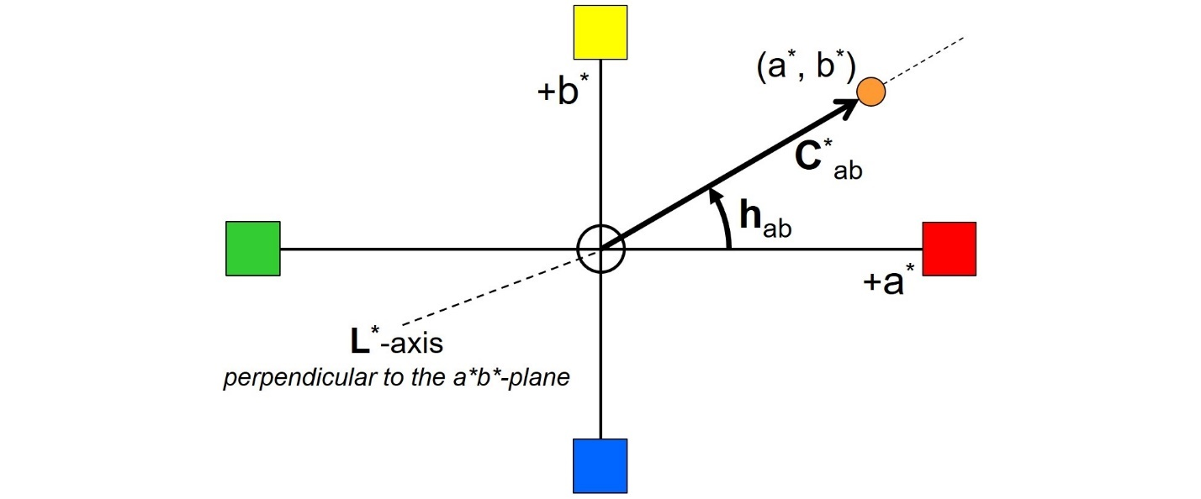Hue angle and chroma in the a*b*-plane

The hue of a color is quantified by its hue angle **hab** (without * symbol) in the a*b*-plane, given in degrees (°). The hue angle range starts, by definition, at the positive side of the a*-axis and goes counter-clockwise. This implies that **red** has a hue angle of 0°. A full circle goes from 0° to 360°. **Cyan blue** (an organic blue pigment with color index PB 15), for example, has a hue angle of about 240°. The hue angle of a color can be calculated from the color coordinates:



The chroma of a color is quantified by **C*ab**; it is the distance of the color point to the L*-axis. Chroma can be calculated from the color coordinates by using Pythagoras’ theorem:



A **saturated** (or **brilliant**) color is represented by a color point that is far away from the lightness axis. The color point of a **pale** (or **dull**, or **pastel**) color, a color of low saturation, is close to the L*-axis.